
Wollo University
Kombolcha Institute of Technology
College of Informatics
Departement of Information Technology

Invetory And Billing Management System(IBMS)

Group Members:
Name ID
- Wondatr Fetene ……………………… 2003/16
- Andargachew Bogale……….………… 0248/16
- Marey Ashaw………………………… 1226/16
- Hussen Ali……………………………… 1071/16
- Meaza Wondye………………………… 1252/16
- Haymanot Fentaw……………………… 1021/16

Advisor’s Name: ……………….
Submission Date:…/…./2018 E.C

Abstract
The Inventory and Billing Management System is a web-based application developed to automate inventory control and billing operations for small to medium-sized organizations. The system integrates concepts from Internet Programming, Database Systems, and Software Engineering to provide a practical and efficient solution. It allows authorized users such as administrators and cashiers to manage products, monitor stock levels, process sales transactions, generate invoices, and produce comprehensive reports.
The system is implemented using PHP for server-side processing and MySQL as the relational database management system, ensuring secure data storage and efficient retrieval. By replacing manual and semi-automated processes, the system minimizes human errors, reduces data redundancy, and improves operational efficiency. Additionally, real-time reporting and role-based access control support better decision-making and data security. Overall, the Inventory and Billing Management System enhances accuracy, reliability, and effectiveness in inventory and billing management.

Abbreviations
IBMS – Inventory and Billing Management System
SRS – Software Requirements Specification
DBMS – Database Management System
CRUD – Create, Read, Update, Delete
UI – User Interface
UAT – User Acceptance Testing
ERD – Entity Relationship Diagram
DFD – Data Flow Diagram
UML – Unified Modeling Language
QA – Quality Assurance
HTML – HyperText Markup Language
CSS – Cascading Style Sheets
JS – JavaScript
PHP – Hypertext Preprocessor
SQL – Structured Query Language
ETB – Ethiopian Birr
VPN – Virtual Private Network
API – Application Programming Interface
HDD – Hard Disk Drive
SSD – Solid State Drive
RAM – Random Access Memory
OS – Operating System

Table of Contents
(To be generated automatically in the final document)

CHAPTER ONE

1 Introduction
Inventory and billing are critical functions for organizations that manage products and sales on a daily basis. Traditional manual or semi-manual methods often lead to errors, data redundancy, poor stock control, and delays in billing and reporting. An Inventory and Billing Management System is designed to address these challenges by providing an automated, reliable, and efficient way to manage products, stock levels, and sales transactions.
This system focuses on integrating inventory control with billing operations to ensure accurate tracking of items from purchase to sale. By using a centralized, web-based platform, the system helps organizations monitor stock availability in real time, generate invoices quickly, reduce human errors, and improve overall operational efficiency.

1.1 Background of the System
Inventory and billing are critical operations in any business environment, as they directly affect product availability, sales accuracy, and financial management. Traditionally, many organizations manage inventory records and billing processes manually or using semi-computerized systems. These approaches often result in data redundancy, calculation errors, loss of records, and inefficient operations, especially as the volume of transactions increases.
With the advancement of web technologies and database systems, there is a growing need for an integrated and automated solution that can efficiently manage inventory and billing activities. A web-based Inventory and Billing Management System enables organizations to centralize data, track stock levels in real time, automate billing processes, and generate accurate reports. Such a system improves operational efficiency, enhances data accuracy, and supports better decision-making.

1.2 Purpose of the System
The purpose of this system is to design and implement a web-based Inventory and Billing Management System that automates product management, stock control, and sales billing processes. The system is intended to replace manual and semi-computerized methods by providing a centralized platform for managing inventory records and billing transactions.
The system aims to ensure accurate tracking of stock levels, automated calculation of sales totals, and secure storage of transaction data. It also seeks to enhance operational efficiency by reducing human errors, minimizing data redundancy, and improving data accessibility. Additionally, the system supports timely report generation and informed decision-making for management through real-time and reliable information.
1.3 Scope of the System
The Inventory and Billing Management System covers core business operations related to inventory control, billing, and reporting. The system provides functionalities for managing products, categories, suppliers, stock levels, sales transactions, and invoice generation. Authorized users such as administrators and cashiers can perform daily operational tasks efficiently through a centralized platform.
The system is accessible through a web browser and supports role-based access to ensure data security and proper authorization. All operational data is stored in a centralized MySQL database, enabling reliable data management, easy retrieval, and consistency across the system. The scope of the system is limited to inventory and billing activities and does not include external accounting or financial management systems.

1.4 Statement of the Problem
Many organizations, particularly small and medium enterprises, continue to rely on manual or semi-computerized inventory and billing processes, which present several challenges:
- Human errors in calculations and record-keeping lead to inaccurate billing and stock discrepancies.
- Data redundancy and inconsistent records make it difficult to track inventory and generate reliable reports.
- Time-consuming processes result in slow customer service and operational delays.
- Lack of real-time information prevents managers from making informed decisions regarding stock levels, sales trends, and purchase planning.
- Poor transparency and accountability increase the risk of losses due to theft, mismanagement, or errors.
The Inventory and Billing Management System addresses these problems by providing an automated, centralized, and secure platform for inventory and sales management, improving accuracy, efficiency, and decision-making across the organization.

1.5 Objectives

1.5.1 General Objective
To develop an integrated Inventory and Billing Management System using PHP and MySQL that improves efficiency, accuracy, and data management.

1.5.2 Specific Objectives
- To design a dynamic web application using PHP
This objective focuses on developing an interactive and responsive web-based system that allows users to perform inventory and billing operations efficiently through a browser-based interface.
- To implement a relational database using MySQL
This objective aims to design and implement a structured and normalized relational database that securely stores inventory, sales, and user data while ensuring data integrity and consistency.
- To manage inventory records and stock levels efficiently
This objective ensures accurate tracking of products and stock quantities, enabling timely updates of inventory levels and preventing stock shortages or overstocking.
- To automate billing and invoice generation
This objective seeks to automate the sales billing process, including price calculation, invoice creation, and transaction recording, thereby reducing manual errors and processing time.
- To generate sales and inventory reports
This objective enables the system to produce timely and accurate reports that support monitoring of business performance and assist management in decision-making.
- To prepare full system development documentation based on SAD principles
This objective ensures that all phases of system development are properly documented following System Analysis and Design principles, including requirements analysis, system design, implementation, testing, and maintenance.

1.6 System Problems
The existing inventory and billing system faces several challenges due to manual or semi-computerized operations. These problems reduce efficiency, accuracy, and reliability of business processes.such as
- Data Entry Errors
Mistakes occur during manual recording of inventory and billing information, leading to inaccurate data.
- Data Redundancy and Inconsistency
Repeated and uncoordinated data entry causes duplicate records and conflicting information.
- Lack of Real-Time Inventory Tracking
Stock levels are not updated immediately after transactions, resulting in overstocking or shortages.
- Slow Billing Process
Invoice preparation takes more time, especially during peak sales periods.
- Incorrect Billing and Pricing
Manual calculations may cause wrong prices, totals, or tax values on invoices.
- Poor Sales Record Management
Sales history is difficult to store, retrieve, and analyze when needed.
- Inefficient Reporting
Generating accurate reports for management requires extra time and effort.
1.7 Limitation of the system
The following constraints and exclusions define the boundaries of the Inventory and Billing Management System. These limitations exist due to constraints related to project scope, time, resources, and technical considerations.

1. Functional Exclusions (What the System Will NOT Do)
The current version of the Inventory and Billing Management System focuses strictly on inventory control and billing operations and will not include the following features:
- Accounting and Financial Reporting:
The system does not provide full accounting functionalities such as profit and loss statements, balance sheets, or tax filing reports.
- Supplier Payment Management:
It does not manage supplier payments, payroll processing, or bank transaction integrations.
- Multi-Branch Support:
The system is designed for a single business location and does not support multiple branches or warehouses without major modification.
- Advanced Analytics and Forecasting:
The system does not include intelligent stock forecasting, demand prediction, or AI-based analytics.
- Mobile Application Support:
The system is web-based only and does not include dedicated mobile applications for Android or iOS platforms.
2. Project & Technical Constraints
- Resource and Time Constraints:
The development of the system is limited by the academic project timeline and available resources, which restricts the implementation of advanced features and large-scale optimization.
- Internet Dependency:
As a web-based application, system access and performance depend on reliable internet connectivity. Poor network conditions may affect system responsiveness.
- Data Migration Challenges:
Initial data entry may require converting existing manual records into digital form, which may introduce temporary data inconsistencies or entry errors.
- Limited Scalability:
The system architecture is optimized for small to medium-scale operations. Significant growth in transaction volume or inventory size may require system redesign or infrastructure upgrades.
- Security Limitations:
Basic security mechanisms are implemented; however, advanced security features such as biometric authentication or intrusion detection systems are beyond the current project scope.

1.8 Beneficiary of the System
The Inventory and Billing Management System is designed to streamline operations, enhance accuracy, and make inventory and sales data more accessible. The system provides significant benefits to various stakeholders, improving overall efficiency, transparency, and service quality.
Admin
- Administrators gain centralized control over user accounts and system permissions.
- The system ensures data security, reducing the risk of unauthorized access.
- Admins can easily monitor system operations, generate reports, and perform maintenance tasks efficiently.
Cashier
- Cashiers experience faster billing processes, allowing them to serve more customers in less time.
- Automated invoice generation reduces human errors in calculations.
- Billing accuracy and speed lead to better customer service and fewer transaction disputes.
Customer
- Customers benefit from quick and precise billing, ensuring correct pricing.
- Reduced waiting times and fewer transaction errors improve overall satisfaction.
- The system contributes to enhanced service delivery, creating a more pleasant shopping experience.
Manager
- Managers can oversee operations through detailed reports and analytics generated by the system.
- They can track sales trends, inventory levels, and employee performance, enabling data-driven decisions.
- The system aids in forecasting demand and planning purchases, reducing stockouts and overstock situations.
Storekeeper
Storekeepers benefit from real-time inventory updates, making stock management easier.
The system alerts them about low-stock or expired items, preventing shortages and wastage.
Automated inventory tracking reduces manual errors and improves inventory accountability.

By addressing the needs of admins, cashiers, customers, managers, and storekeepers, the system enhances operational efficiency, transparency, and overall service quality, ensuring smooth workflow and informed decision-making.

1.9 System Methodology
This section describes the approaches used to collect system requirements and to develop the Inventory and Billing Management System in an organized and effective manner.

1.9.1 Data Gathering Methodology
To understand the existing problems and user requirements, different data gathering techniques were used:
- Interviews
Interviews were conducted with business owners, store managers, and sales staff to collect detailed information about current inventory and billing procedures, challenges, and user expectations.
- Observation
Direct observation of daily inventory handling and billing activities was carried out to understand real-world workflows, transaction processes, and common errors in the existing system.
- Document Review
Existing documents such as stock records, invoices, receipts, and reports were reviewed to identify data structures, business rules, and reporting requirements.
- Questionnaires
Simple questionnaires were used to gather feedback from users regarding system usability, required features, and areas needing improvement.

1.9.2 System Development Methodology
The Waterfall Development Model was used for the development of the Inventory and Billing Management System because of its clear structure and suitability for academic projects.
The development followed these phases:
- Requirement Analysis
System requirements were clearly identified and documented based on the collected data.
- System Design
Database design, system architecture, and user interface designs were prepared before implementation.
- Implementation
The system was developed using PHP for the application logic and MySQL for database management.
- Testing
Functional and non-functional testing were performed to ensure the system meets user requirements and works correctly.
- Deployment and Maintenance
The system was deployed for use, and basic maintenance activities such as bug fixing and updates were planned.

1.10 Feasibility Study

1. Economic Feasibility
The implementation of the Inventory and Billing Management System is economically advantageous for the organization. Manual inventory management and billing processes often result in inefficiencies such as human errors, miscalculations, stock discrepancies, and delays in generating invoices. Automating these processes significantly reduces these issues, leading to better resource utilization and financial management.
Key Points:
- Reduction of Operational Costs: By automating inventory updates and billing, the system minimizes labor costs and reduces the need for additional staff to manage stock and sales manually.
- Improved Accuracy: Automated billing reduces errors that could lead to financial losses or customer dissatisfaction.
- Faster Transactions: Real-time inventory updates allow faster billing, improving cash flow and customer satisfaction.
- Long-term Savings: Although initial setup may incur costs, the system reduces recurring expenses associated with manual processes, such as paperwork, printing invoices, and reconciliation efforts.
Example: A shop previously needed 3 employees to manage inventory and billing. With the system, one employee can manage the same workload, saving significant salary expenses annually.

2. Political/Organizational Feasibility
The system aligns well with organizational goals and policies, making its implementation politically feasible. There are no legal or policy restrictions preventing the automation of inventory and billing systems. Moreover, management generally supports technological upgrades that improve efficiency and accountability.

Key Points:
- Management Support: The system ensures transparent and accurate tracking of stock and sales, which aligns with organizational objectives for accountability.
- Stakeholder Acceptance: Employees and management are likely to adopt the system because it simplifies their workflow and reduces repetitive tasks.
- Compliance: The system allows easy generation of reports required for internal audits, tax reporting, and regulatory compliance.
- Conflict Minimization: Clearly defined roles and access levels in the system prevent misuse and reduce internal conflicts.
Example: Managers can access real-time sales reports without waiting for manual summaries, which reduces delays in decision-making and potential disputes among staff.

3. Technical Feasibility
The technical feasibility examines whether the current technology and skills are sufficient to develop and operate the system effectively.
Technical Considerations:
Development Platform: PHP is chosen for web development due to its reliability, ease of use, and wide community support.
Database Management: MySQL is used to create a relational database, ensuring data integrity, consistency, and easy retrieval of information.
User Interface: HTML, CSS, and JavaScript are used to build an interactive and user-friendly web interface for both desktop and mobile access.
Security Measures: The system supports user authentication, password encryption, and role-based access control to protect sensitive data.
Hardware Requirements: The system can run on existing office computers with minimal additional hardware costs.
Advantages:
Low technical risk since PHP and MySQL are mature and well-documented technologies.
Developers are readily available, and training for existing staff can be completed quickly.
The system supports future scalability, allowing integration of additional features like barcode scanning, SMS notifications, and online payment integration.

4. Cost Feasibility:
Cost-Benefit Analysis
The Cost-Benefit Analysis evaluates whether the benefits of implementing the Inventory and Billing Management System outweigh the costs of development, deployment, and maintenance. It considers both tangible and intangible costs and benefits to provide a clear picture of economic feasibility.

Tangible Benefits
- Reduced Administrative Costs: Significant savings on administrative processes through the automation of inventory tracking, sales transactions, and invoice generation, which were previously manual and time-consuming.
- Reduced Resource Expenditure: Savings on physical resources such as paper, pens, and printing materials that were extensively used in manual record-keeping and billing.
- Minimizing Stock Loss: The system reduces the risk of inventory errors or losses due to human mistakes, which was a major problem in the manual system.

Intangible Benefits
- Improved Efficiency: The automated system will make inventory management and billing processes faster and more efficient for both staff and management.
- Enhanced Customer Satisfaction: Customers and clients benefit from faster, error-free billing and accurate stock availability information.
- Increased Accuracy: The system reduces calculation and record-keeping errors, ensuring that inventory levels and billing records are precise.
- Improved Organizational Reputation: Adoption of a modern, automated system will enhance the organization’s reputation for professionalism and technological capability.
- Licensing Savings: There are no licensing costs as the project uses open-source technologies (PHP, MySQL, Apache).

Intangible Costs
- Learning Curve: Users, particularly staff accustomed to manual processes, may need time and training to adapt to the new system.
- Initial Disruption: Temporary operational disruption may occur during the transition, system deployment, and data migration phases.
- Resistance to Change: Some employees or stakeholders may be reluctant to adopt the new automated system due to familiarity with the existing manual process.
The Cost-Benefit Analysis confirms that implementing the Inventory and Billing Management System is economically justified. Both tangible and intangible benefits outweigh the costs, ensuring a positive return on investment and long-term advantages for the organization.

5. Operational Feasibility:
Operational feasibility assesses whether the system can be integrated into existing operations and whether employees can efficiently use it.
Operational Benefits:
- Automation of Daily Tasks: Billing, inventory tracking, and report generation are fully automated.
- Real-Time Updates: Stock levels, sales, and inventory movements are updated instantly, reducing delays and errors.
- User-Friendly Interface: Staff with minimal computer skills can quickly adapt to the system.
- Enhanced Decision-Making: Managers receive timely and accurate information for planning and procurement.
- Scalability: The system can handle increased transactions and inventory as the organization grows.
Implementation Considerations:
- Short training sessions for staff to familiarize themselves with the system.
- Gradual migration from manual to automated processes to minimize disruption.
- Regular monitoring and feedback collection to improve system performance.

1.11 Significance of the System
The Inventory and Billing Management System plays a vital role in improving the efficiency, accuracy, and productivity of any organization that deals with inventory and sales. Its significance lies in automating processes that were traditionally manual, time-consuming, and error-prone.

Efficiency Improvement

Automates routine tasks such as stock updates, invoice generation, and sales recording.
- educes the time required for inventory management and billing processes.
- Enables quick retrieval of stock information, sales history, and reports.
Example: Instead of manually counting inventory and preparing invoices, the system can generate real-time stock levels and invoices within seconds.
2. Accuracy and Error Reduction
- Minimizes human errors in billing, stock tracking, and data entry.
- Prevents discrepancies between recorded and actual inventory.
- Ensures accurate financial records for auditing and reporting.
Example: Automatic calculation of totals, taxes, and discounts prevents miscalculations that could lead to financial losses.

3. Cost Savings
- Reduces labor costs by decreasing the need for additional staff to manage inventory and billing.
- Prevents financial losses caused by stock mismanagement, overstocking, or understocking.
- Reduces printing and paperwork costs by digitizing invoices, reports, and records.

4. Better Decision-Making
- Provides real-time reports on sales, inventory levels, and stock movement.
- Assists management in planning purchases, identifying fast- and slow-moving items, and optimizing inventory levels.
- Supports strategic decisions like pricing, promotions, and procurement.

5. Improved Customer Satisfaction
- Speeds up the billing process, reducing waiting time for customers.
- Ensures products are available when needed due to accurate inventory tracking.
- Provides professional and error-free invoices, improving customer trust.

6. Data Security and Accountability
- Ensures that only authorized users can access sensitive data through login credentials and role-based access.
- Maintains a secure and reliable record of transactions, reducing the risk of fraud.
- Facilitates auditing by keeping detailed logs of inventory and sales activities.

7. Scalability and Future Expansion
- The system can easily be expanded to include additional modules like online ordering, barcode scanning, supplier management, or integration with mobile apps.
- Supports growing businesses by managing larger inventories and higher transaction volumes efficiently.

1.12 Budget of the System
The budget estimation for the Inventory and Billing Management System considers all the necessary expenses required for development, deployment, and maintenance. The budget is categorized into software, hardware, development, training, and maintenance costs.

1. Software Costs
- Web Development Tools: PHP, MySQL, Apache – Open-source, free of cost.
- Additional Software: Optional tools like Visual Studio Code, Git for version control – free or minimal cost.
- Estimated Cost: 0 – 5,000 ETB (for optional paid tools or plugins)

2.Hardware Costs

Server/Computer: Existing office desktops and server will be used. If a dedicated server is required:
- Mid-range server: ~50,000 ETB
- Backup storage devices: ~10,000 ETB
Estimated Cost: 0 – 60,000 ETB
3. Development Costs
This includes labor costs for software developers, database designers, and testers.
Item | Quantity | Unit Cost (ETB) | Total Cost (ETB)
Software Developer | 2 | 15,000 | 30,000
Database Designer | 1 | 12,000 | 12,000
Tester/QA | 1 | 10,000 | 10,000
Documentation/Technical Writer | 1 | 8,000 | 8,000
Estimated Total Development Cost: 60,000 ETB

4. Training Costs
- Training staff to use the system efficiently.
- Includes training materials, sessions, and hands-on practice.
Item | Quantity | Unit Cost (ETB) | Total Cost (ETB)
Staff Training Session | 1 | 5,000 | 5,000
Training Materials | 1 | 2,000 | 2,000
Estimated Total Training Cost: 7,000 ETB

Maintenance Costs

Ongoing maintenance to fix bugs, update the system, and perform backups.

Estimated annually.
Item | Quantity | Unit Cost (ETB) | Total Cost (ETB)
System Maintenance | 12 months | 1,500/month | 18,000
Backup & Recovery Tools | - | 2,000 | 2,000
Estimated Total Annual Maintenance Cost: 20,000 ETB

6. Contingency Cost
10% of total budget for unforeseen expenses such as hardware replacement, additional software, or extra development work.
Estimated Contingency: ~14,000 ETB
7. Total Estimated Budget
Category | Cost (ETB)
Software Costs | 5,000
Hardware Costs | 60,000
Development Costs | 60,000
Training Costs | 7,000
Maintenance Costs | 20,000
Contingency | 14,000
Total Budget | 166,000 ETB

1.13 Schedule of the System
The schedule provides a detailed timeline for the development, testing, and deployment of the Inventory and Billing Management System. The project will follow a Waterfall/Agile hybrid model, with clearly defined phases to ensure timely completion.
Project Phases and Timeline
Phase | Tasks / Activities | Duration | Responsible Party
1.Requirement Analysis | - Gather requirements from stakeholders  - Conduct interviews and surveys  - Prepare SRS draft | 2 weeks | System Analysts, Project Team
2. System Design | - Design system architecture  - Prepare ERD, DFD, Class Diagrams  - UI mockups | 2 weeks | System Analysts, Designers
3.Database Development | - Create database schema  - Define tables, relationships, and constraints  - Implement backup/restore plan | 1 week | Database Developer
4.System Implementation | - Develop front-end (HTML/CSS/JS)  - Develop back-end (PHP)  - Implement CRUD operations and transactions | 3 weeks | Developers
5.System Integration | - Integrate front-end, back-end, and database  - Conduct initial testing | 1 week | Developers, Testers
6. Testing Phase | - Unit Testing  - Integration Testing  - System Testing  - UAT (User Acceptance Testing) | 2 weeks | Testers, End-Users
7. Deployment | - Install system on live server  - Configure user access  - Backup and restore | 1 week | IT Staff, Project Team
8.Training & Documentation | - Train staff on system use  - Prepare User Manual and Maintenance Guide | 1 week | Project Team, Trainers
9. Maintenance & Support | - Bug fixes and updates  - Monitor system performance  - Periodic backups | Ongoing (Post-Deployment) | IT Support Team

CHAPTER TWO
SOFTWARE REQUIREMENTS SPECIFICATION (SRS)

2.1 Proposed Solution
The proposed solution is a web-based Inventory and Billing Management System designed to automate and integrate inventory control, sales processing, and billing operations into a single, centralized system. The system replaces manual and semi-automated processes with a reliable digital platform that improves accuracy, efficiency, and decision-making.
The system will be developed using PHP as the server-side programming language and MySQL as the relational database management system. It will be accessible through a standard web browser, allowing authorized users to manage inventory and billing operations from any connected device.

Features of the Proposed Solution

1. User Management
The system provides a secure user management module that controls access to system functionalities based on user roles. Each user must authenticate using a unique username and password before accessing the system. Role-based access control ensures that users can only perform actions permitted by their responsibilities, such as administrators managing system settings, storekeepers updating inventory, cashiers handling billing, and managers viewing reports. All user activities are logged to improve accountability and traceability.

2. Inventory Management
The inventory management module allows authorized users to manage all product-related information efficiently. Users can add new products, update existing product details, delete obsolete items, and categorize products for better organization. The system tracks stock levels in real time and automatically updates quantities after each sales transaction. Low-stock alerts are generated to notify users when inventory reaches a predefined threshold, helping prevent stock shortages and overstocking. Supplier information is also maintained to support procurement planning.

3. Billing and Sales Management
The billing and sales module automates the sales process by generating invoices for every transaction. The system calculates item totals, taxes, discounts, and final payable amounts accurately. It supports different payment methods such as cash and credit. Each transaction is recorded and stored in the database, allowing users to retrieve past sales records for reference, auditing, and customer service purposes. The system ensures that inventory levels are automatically adjusted once a sale is completed.

4. Reporting and Analytics
The reporting module provides comprehensive and up-to-date information about inventory and sales performance. Users can generate daily, weekly, monthly, and annual reports related to sales, revenue, stock status, and product movement. These reports assist management in identifying fast-moving and slow-moving items, monitoring profit trends, and making informed decisions related to purchasing and pricing strategies.

5. Database Management
The system uses a centralized relational database to store and manage all inventory, billing, and user-related data. The database is properly normalized to reduce data redundancy and maintain data consistency. Relationships between entities such as products, users, sales, and invoices are enforced using primary and foreign keys. Regular database backup and restore mechanisms are implemented to ensure data safety and business continuity in case of system failure or data loss.

6. System Security and Reliability
Security is a critical aspect of the proposed system. User passwords are encrypted before being stored in the database, and secure session management is implemented to prevent unauthorized access. Input validation and error handling mechanisms protect the system from invalid data entry and common security threats. The system is designed to be reliable and available, ensuring continuous operation during business hours and maintaining data integrity at all times.

2.2 System Workflow
The system workflow describes the sequence of activities performed by users and the system to manage inventory and billing operations. The workflow ensures that all processes—from user authentication to reporting—are executed in an organized, secure, and efficient manner.

Step 1: User Authentication
- The user accesses the system through a web browser.
- The system prompts the user to enter login credentials (username and password).
- The system validates the credentials against the database.
- If authentication is successful, the user is redirected to the dashboard based on their role.
- If authentication fails, an error message is displayed.

Step 2: Dashboard Access
- After successful login, the user views a role-based dashboard.
- The dashboard displays available system modules such as inventory management, billing, reports, and user management.
- Users can only access functions permitted by their assigned roles.

Step 3: Inventory Management Process
- Authorized users can add new products by entering product details such as name, category, price, quantity, and supplier.
- The system validates the entered data and stores it in the database.
- Users can update product information or remove obsolete items.
- The system continuously monitors stock levels and updates quantities in real time.
- When stock reaches a minimum threshold, the system generates a low-stock notification.

Step 4: Billing and Sales Process
- The cashier selects products for a sales transaction.
- The system retrieves product prices and available quantities from the inventory.
- The system calculates the total amount, applicable taxes, and discounts automatically.
- An invoice is generated and displayed for confirmation.
- After payment confirmation, the system:
- Records the transaction in the sales database.
- Automatically reduces inventory stock levels.
- Stores the invoice for future reference.

Step 5: Reporting and Monitoring

Authorized users generate sales and inventory reports.
- Reports can be produced daily, weekly, monthly, or annually.
- The system retrieves data from the database and presents it in structured formats.
- Management uses reports to analyze sales performance and inventory status.

Step 6: Database Backup and Recovery
- The system performs scheduled database backups.
- In case of system failure or data loss, authorized users can restore data from backup files.
- This ensures data integrity and business continuity.

Step 7: Logout and Session Termination
- Users log out after completing tasks.
- The system terminates the session securely.
- Unauthorized access after logout is prevented.

Summary
The workflow ensures a smooth flow of operations, where inventory updates, billing, and reporting are tightly integrated. Each transaction triggers real-time updates in the database, maintaining data accuracy and system reliability.

2.3 System Advantages
The Inventory and Billing Management System provides several advantages over manual and semi-automated systems. These advantages contribute to improved efficiency, accuracy, security, and overall organizational performance.

Improved Operational Efficiency
The system automates inventory control and billing processes, significantly reducing the time required to perform daily operations. Tasks such as updating stock levels, generating invoices, and preparing reports are completed quickly and accurately, enabling employees to focus on more productive activities.

Accuracy and Error Reduction
Manual calculations and data entry often lead to errors in inventory records and billing. The proposed system performs automatic calculations for totals, taxes, and discounts, minimizing human errors. Real-time inventory updates ensure that stock records remain accurate and reliable.
- Real-Time Inventory Tracking
The system provides up-to-date information on stock availability at all times. Automatic stock adjustments after each sale prevent inconsistencies and help avoid over-stocking or stock-out situations. Low-stock alerts assist in timely replenishment of products.

Faster and Professional Billing
Automated invoice generation reduces customer waiting time and ensures professional billing. The system generates clear, consistent, and error-free invoices, improving customer satisfaction and trust.

Better Decision-Making Support
The reporting and analytics module provides accurate sales and inventory reports. Management can analyze trends, identify fast-moving and slow-moving products, and make informed decisions related to purchasing, pricing, and inventory planning.

Data Security and Access Control
The system enforces secure login and role-based access control to protect sensitive inventory and financial data. Only authorized users can access specific system functions, ensuring confidentiality, integrity, and accountability.

Cost Reduction
By reducing paperwork, minimizing errors, and lowering labor requirements, the system helps reduce operational costs. Efficient inventory management also prevents financial losses caused by expired, damaged, or misplaced items.

Scalability and Flexibility
The system is designed to support future growth and enhancements. Additional features such as barcode scanning, supplier integration, online sales, and mobile access can be incorporated without major system changes.

2.4 System Business Rules
System business rules define the policies, conditions, and constraints that govern how the Inventory and Billing Management System operates. These rules ensure consistency, accuracy, security, and compliance with organizational procedures.

1. User Access and Authorization Rules
- Only registered users with valid login credentials are allowed to access the system.
- Each user must be assigned a specific role (Admin, Storekeeper, Cashier, Manager).
- Users can only perform actions permitted by their assigned roles.
- Administrative functions such as user creation and system configuration are restricted to administrators only.

2. Inventory Management Rules
- Every product must have a unique product identification number.
- Products must be assigned to a valid category and supplier.
- Stock quantity cannot be negative under any circumstance.
- Inventory levels must be automatically updated after every sales transaction.
- Products reaching the minimum stock level must trigger a low-stock alert.

3. Billing and Sales Rules
- A sale transaction cannot be completed if the requested quantity exceeds available stock.
- An invoice must be generated for every completed sales transaction.
- The system must automatically calculate total price, tax, discount, and final payable amount.
- Each invoice must have a unique invoice number.
- Sales transactions must be stored permanently for auditing and reporting purposes.

4. Data Validation Rules
- Mandatory fields (such as product name, price, quantity, and user credentials) must not be left empty.
- Numeric fields (price, quantity, discount) must accept only valid numeric values.
- Duplicate records for products, users, and invoices must be prevented.
- Invalid or incomplete data entries must be rejected by the system.

5. Security Rules
- User passwords must be stored in encrypted form.
- User sessions must expire automatically after a defined period of inactivity.
- Unauthorized access attempts must be logged for security monitoring.
- Sensitive operations such as deleting records must require proper authorization.

6. Reporting Rules
- Only authorized users can generate and view reports.
- Reports must reflect real-time data from the database.
- Generated reports must be accurate, complete, and tamper-proof.

7. Backup and Recovery Rules
- The system must perform regular database backups.
- Backup data must be securely stored.
- Only authorized personnel can perform data restoration.

These business rules ensure that the Inventory and Billing Management System operates in a controlled, secure, and consistent manner. By enforcing these rules, the system maintains data integrity, prevents misuse, and supports reliable business operations.

2.5 Functional Requirements(the system must perform)
Functional requirements define the specific behaviors and functions that the Inventory and Billing Management System must perform. These requirements describe how the system responds to user actions and how it manages data and processes.

User Authentication and Authorization
- The system shall allow users to log in using a valid username and password.
- The system shall verify user credentials before granting access.
- The system shall assign permissions based on user roles.
- The system shall prevent unauthorized users from accessing restricted functionalities.
- The system shall allow administrators to create, update, and deactivate user accounts.

Product Management
- The system shall allow authorized users to add new products.
- The system shall allow users to update existing product details.
- The system shall allow users to delete or deactivate products.
- The system shall ensure that each product has a unique identifier.
- The system shall store product information such as name, category, price, quantity, and supplier.

Inventory Control
- The system shall track inventory quantities in real time.
- The system shall automatically update stock levels after sales transactions.
- The system shall prevent stock quantity from becoming negative.
- The system shall generate alerts when stock reaches a minimum threshold.
- The system shall allow users to view current inventory status.

Billing and Sales Processing
- The system shall allow users to create a new sales transaction.
- The system shall calculate the total price of selected products automatically.
- The system shall apply taxes and discounts as defined by business rules.
- The system shall generate a unique invoice for each completed sale.
- The system shall store sales transaction details in the database.

Invoice Management
- The system shall display generated invoices on the screen.
- The system shall allow invoices to be printed or saved electronically.
- The system shall allow authorized users to retrieve previous invoices.
- The system shall ensure invoice data cannot be modified after finalization.

Supplier Management
- The system shall allow authorized users to add and manage supplier information.
- The system shall store supplier details such as name, contact information, and address.
- The system shall associate products with their respective suppliers.

- Reporting and Analytics
- The system shall generate inventory reports.
- The system shall generate sales reports based on specified time periods.
- The system shall allow authorized users to view and export reports.
- The system shall ensure reports reflect real-time data.

Data Management
- The system shall store all data in a centralized relational database.
- The system shall ensure data consistency and integrity using constraints.
- The system shall allow authorized users to update and retrieve stored data.

Backup and Recovery
- The system shall perform regular database backups.
- The system shall allow authorized users to restore data from backups.
- The system shall protect backup data from unauthorized access.

System Logout

The system shall allow users to log out securely.
- The system shall terminate user sessions after logout or inactivity.

2.6 Non-Functional Requirements
Non-functional requirements define the quality attributes, performance standards, and constraints of the Inventory and Billing Management System. These requirements ensure that the system operates efficiently, securely, reliably, and is user-friendly.

Performance Requirements
- The system shall respond to user requests within an acceptable time (e.g., less than 3 seconds for common operations).
- The system shall support multiple concurrent users without performance degradation.
- Invoice generation and stock updates shall be processed in real time.

Security Requirements
- The system shall require authentication for all users.
- User passwords shall be encrypted before being stored in the database.
- The system shall implement role-based access control.
- Unauthorized access attempts shall be logged.
- Sensitive data shall be protected from unauthorized modification or disclosure.

Reliability and Availability
- The system shall be available during business hours with minimal downtime.
- The system shall ensure data consistency and integrity at all times.
- The system shall recover gracefully from failures using backup and restore mechanisms.
- Usability Requirements
- The system shall provide a simple, intuitive, and user-friendly interface.
- Users with basic computer skills shall be able to use the system with minimal training.
- Error messages shall be clear and informative.
- Maintainability
- The system shall be modular to allow easy updates and bug fixes.
- Source code shall follow standard coding practices and documentation.
- The system shall allow future enhancements without major redesign.

Scalability
- The system shall handle increasing numbers of products, users, and transactions.
- The database shall support growth without affecting system performance.

Compatibility
- The system shall be compatible with major web browsers (Chrome, Firefox, Edge).
- The system shall operate on common operating systems (Windows, Linux).

Backup and Recovery

The system shall perform scheduled database backups.
- Backup data shall be stored securely.
- The system shall allow authorized users to restore data when required.

2.7 System Constraints
System constraints define the limitations, restrictions, and conditions under which the Inventory and Billing Management System must operate. Identifying these constraints helps ensure realistic planning, development, and deployment of the system.

Hardware Constraints
The system shall run on existing office computers and servers with minimum specifications:
- Processor: Intel i3 or equivalent
- RAM: 4 GB or higher
- Storage: 500 GB HDD/SSD or higher
- If a dedicated server is used, it must support multi-user access and real-time database operations.

Software Constraints
- The system shall be developed using PHP (version 7.4 or higher).
- The database shall use MySQL (version 5.7 or higher).
- The system shall be compatible with major web browsers such as Google Chrome, Mozilla Firefox, and Microsoft Edge.
- Operating systems must be Windows 10/11 or Linux for server deployment.

Network Constraints
- The system shall require an active internet or local network connection for multi-user access.
- Network speed should be sufficient to support real-time data updates (recommended 10 Mbps or higher).
- Users accessing the system remotely must have secure VPN or restricted network access.

User Constraints
- Users must have basic computer skills to operate the system.
- Users must be assigned roles and permissions before accessing system functionalities.
- Unauthorized users are not permitted to access or manipulate system data.

Database Constraints
- All data must follow relational database constraints to maintain integrity.
- Stock quantity must always be non-negative.
- Product IDs, invoice numbers, and user IDs must be unique.
- Backup and restore operations must comply with predefined schedules to prevent data loss.

Operational Constraints
- The system shall operate during normal business hours but must be available for emergency access if required.
- System downtime for maintenance shall be scheduled in advance and minimized.
- Regular database backups are mandatory to ensure continuity in case of failure.

Security Constraints
- All sensitive data (user credentials, sales, and inventory data) must be encrypted.
- Access control rules must be strictly enforced to prevent unauthorized operations.
- System logs shall be maintained for auditing and security monitoring.
These constraints define the operational, technical, and security boundaries of the system. Awareness of these limitations ensures that the Inventory and Billing Management System is developed, deployed, and operated successfully without violating organizational policies or system capabilities.

CHAPTER THREE
SYSTEM ANALYSIS

3.1 Overview of the Use-Case Diagram
The Use-Case Diagram represents the functional interactions between system users (actors) and the Inventory and Billing Management System. It shows what the system does from the user’s point of view, not how it is implemented.
This diagram helps to:
- Identify system functionality
- Clarify user responsibilities
- Define system boundaries
- Serve as a foundation for functional requirements

3.1 .2 Description of the Use-Case Diagram
The Use-Case Diagram illustrates the interaction between users and the Inventory and Billing Management System. It describes the system’s functional requirements by showing what actions users can perform and how they communicate with the system. This diagram helps in understanding system behavior from the user’s perspective and defines the scope of the system.
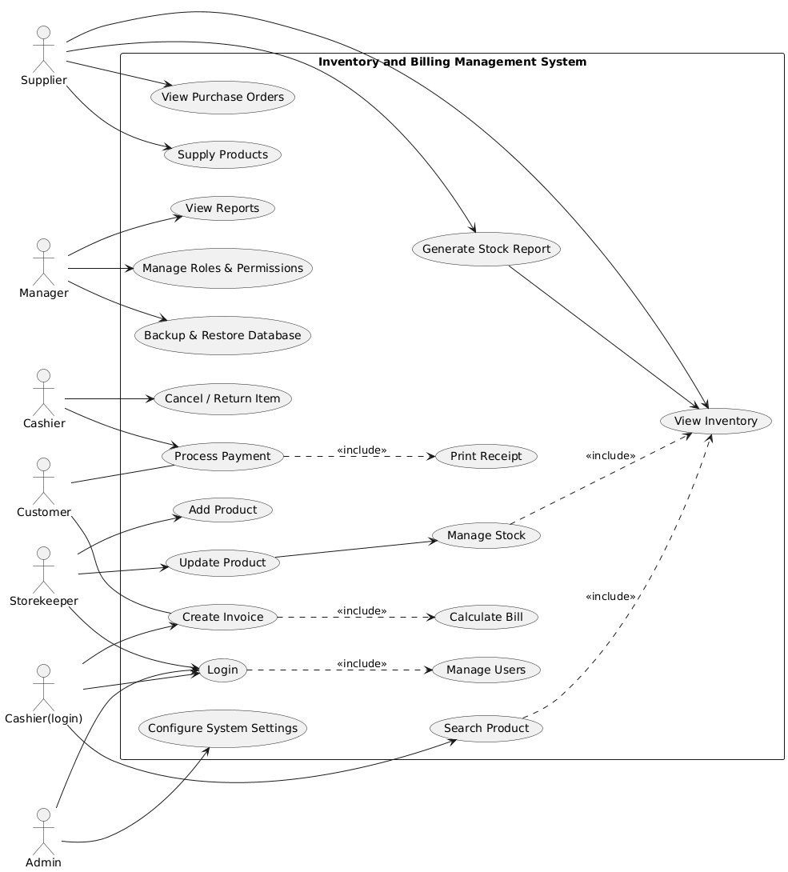
Fig 3.1 use case diagram

3.1.3 Actors of the System
The system consists of six main actors:
i. Admin/Owner – Responsible for overall system administration, user management, and system configuration.
ii. Cashier – Handles daily billing operations and payment processing for customers.
iii. Manager – Oversees business operations, manages roles and permissions, and analyzes system reports for decision-making.
iv. Storekeeper – Responsible for inventory management, including adding new products, updating stock levels, and monitoring product availability.
v. Customer – Interacts indirectly with the system through purchases and billing.
vi. Supplier – Provides goods to the business and interacts with the system via purchase orders and supply records.

3.1.4 Use-Cases and Responsibilities

Admin Use-Cases
The Admin manages the system configuration and user access.
- Login and Logout
- Add, update, and delete users
- Add, update, and delete inventory items
- Set and update item prices
- View system-wide reports
- Perform database backup and restore

Cashier Use-Cases
Cashiers perform operational tasks related to billing and sales.
- Login and Logout
- View available items
- Create sales invoice
- Generate customer bill
- Process payment
- Update item quantity after sales
- Search items in the inventory

Manager Use-Cases
The Manager monitors business operations and performance.
- Login and Logout
- View inventory status reports
- View sales reports
- Monitor low-stock items
- Review cashier performance

Customer Use-Cases
Customers benefit from the system indirectly through:
- Receiving accurate bills
- Ensuring correct item pricing
- Efficient purchase processing and payment
- Storekeeper Use-Cases
The Storekeeper is responsible for the day-to-day accuracy of the inventory and stock levels.
- Login and Logout: Access the inventory module securely.
- Add New Products: Register new items into the system database as they arrive.
- Update Stock Levels: Manually adjust stock quantities after receiving new shipments or performing physical audits.
- Categorize Items: Organize inventory by type, brand, or location for easier retrieval.
- Monitor Expiry Dates: Track and manage perishable or time-sensitive items (if applicable).
- View Inventory Status: Check current stock levels to ensure data matches the physical shelf.
- Notify Low Stock: Flag items that have reached the reorder point to prevent stockouts.

3.1.5 Use-Case Relationships
- All actors must login before accessing system functionalities.
- The Generate Bill use-case is dependent on the Create Invoice use-case.
- Inventory quantity is automatically updated after billing is completed.
The Use-Case Diagram clearly defines the interactions between Admin, Cashier, Manager, and Customer with the Inventory and Billing Management System. It ensures proper role separation, secure access, accurate inventory management, and efficient billing processes.

3.2 Use-Case Descriptions
System: Inventory and Billing Management System
Actors: Admin, Cashier, Manager, Customer

3.2.1 Use Case: Login
Actor: Admin, Cashier, Manager
Description: Allows authorized users to access the system with valid credentials.
Precondition: User must be registered in the system.
Main Flow:
- User opens the login page.
- User enters username and password.
- System validates the credentials.
- System grants access to the dashboard.
Postcondition: User successfully logged into the system.

3.2.2 Use Case: Manage Items (Inventory)
Actor: Admin/owner
Description: Allows the admin to add, update, view, and delete items in the inventory.
Precondition: User must be logged in as Admin.
Main Flow:
- User selects inventory management.
- User adds new item or updates existing item.
- System saves item details (name, quantity, price).
- System displays updated inventory list.
Postcondition: Inventory data is updated successfully.

3.2.3 Use Case: Update Stock Quantity
Actor: Admin
Description: Enables updating stock quantity when new items arrive.
Precondition: Item must already exist in inventory.
Main Flow:
- Admin selects an item.
- Enters new quantity.
- System updates stock level.
Postcondition: Stock quantity is updated.

3.2.4 Use Case: Generate Bill
Actor: Cashier
Description: Allows the cashier to create a bill for customer purchases.
Precondition: Cashier must be logged in; item must be available in stock.
Main Flow:
- Cashier selects items for sale.
- System calculates total price.
- System generates a bill.
- Bill is displayed/printed.
Postcondition: Bill is generated and stored.

3.2.5 Use Case: Process Payment
Actor: Cashier
Description: Handles payment processing after bill generation.
Precondition: Bill must be generated.
Main Flow:
- Cashier selects payment method.
- Customer pays the amount.
- System confirms payment.
- System updates inventory.
Postcondition: Payment recorded and stock reduced.

3.2.6 Use Case: View Sales Report
Actor: Manager, Admin
Description: Allows viewing daily, monthly, or yearly sales reports.
Precondition: User must be logged in as Manager or Admin.
Main Flow:
- User selects report type.
- System generates sales report.
- Report is displayed.
Postcondition: Sales report is available for review.

3.2.7 Use Case: Manage Users
Actor: Admin
Description: Allows the admin to add, update, or remove system users.
Precondition: Admin must be logged in.
Main Flow:
- Admin opens user management.
- Adds or modifies user details.
- System saves changes.
Postcondition: User accounts are updated.

3.2.8 Use Case: Logout
Actor: All Users
Description:This use case allows users to safely exit the system.
Precondition:User must be logged in.
Main Flow:
- User selects logout option.
- System ends the session.
Postcondition:User is logged out successfully.

3.2.9 Use Case: Inventory & Stock Management (Storekeeper)
Actor: Storekeeper
Description: The Storekeeper is responsible for the physical accuracy of the warehouse and the digital entry of stock data.
Specific Responsibilities:
- Inventory Operations (Related to 3.2.2): Unlike the Admin who "manages" the system, the Storekeeper performs the actual data entry for adding and viewing items. They ensure that every item on the shelf is correctly represented in the system.
- Stock Replenishment (Related to 3.2.3): The Storekeeper is the primary actor for Updating Stock Quantity. When a shipment arrives from a Supplier, the Storekeeper verifies the quantity and updates the system to reflect the new stock levels.
- Stock Monitoring: The Storekeeper monitors inventory levels to identify "Low Stock" situations, ensuring the Cashier never runs out of items to sell.
- Inventory Validation: They perform periodic stock takes (comparing physical counts to system counts) to ensure the "Update Stock Quantity" flow is accurate.

3.3 Context Diagram (DFD Level 0)
The Context Diagram (DFD Level 0) represents the entire Inventory and Billing Management System as one single process and shows how it interacts with external entities. It does not show internal data stores or detailed processes.

3.3.1 External Entities and Data Flow

1. Admin/owner
Inputs to System:
- User details
- Item details
- System configuration data
Outputs from System:
- User management confirmation
- Inventory reports
- System status information

3. Cashier
Inputs to System:
- Sales item details
- Payment information
Outputs from System:
- Generated bill
- Payment confirmation
- ntory report

5. Customer (External Entity)
Inputs to System:
- Purchase request
- Payment
Outputs from System:Bill/Receipt

3.3.2 Central Process
Process Name: Inventory and Billing Management System
- This central process:
- Manages inventory records
- Handles billing and payment
- Generates reports
- Controls users and system operations
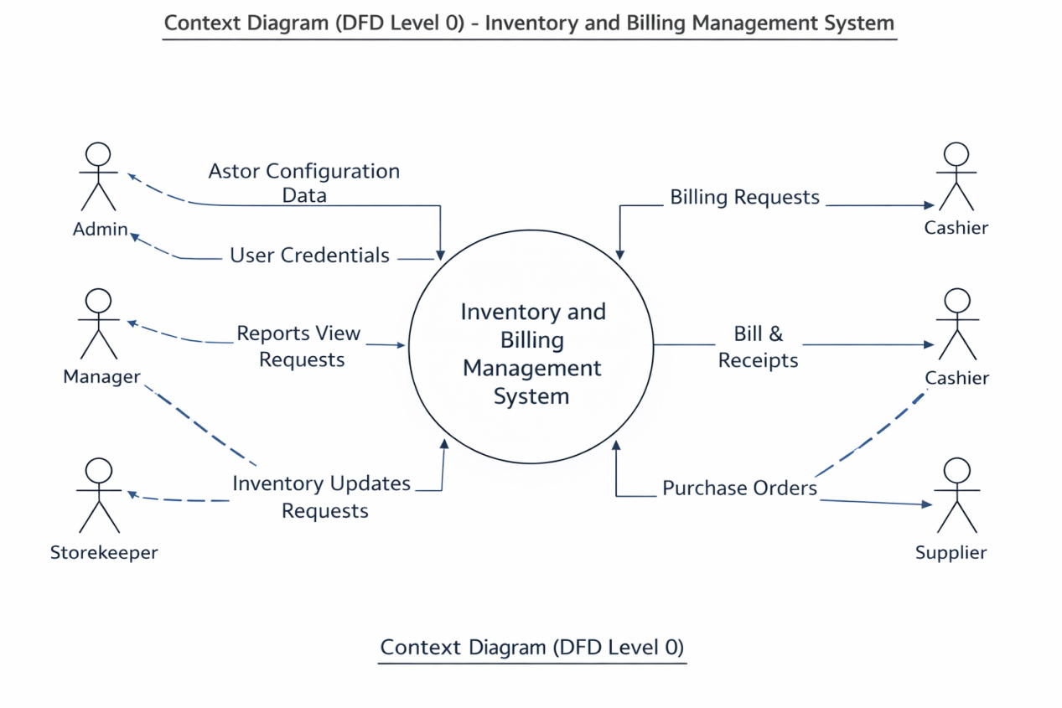
Fig 3.2 DFD diagram level 0

3.4 DFD (Level 1)

Process 1: User Management
Inputs:User details (from Admin)
Outputs:
- Login confirmation
- User access permission
Data Store:
D1: User Database

Process 2: Inventory Management
Inputs:
- Item details (from Admin)
- Stock update details (from Storekeeper)
Outputs:
- Inventory status
- Stock confirmation
Data Store:
D2: Inventory Database

Process 3: Billing & Sales Processing
Inputs:
- Purchase details (from Cashier)
- Payment information (from Customer)
Outputs:
- Bill / Receipt
- Payment confirmation
Data Stores:
D2: Inventory Database
D3: Sales Database

Process 4: Report Management
Inputs:Report request (from owner/Admin)
Outputs:
- Sales report
- Inventory report
Data Stores:
D2: Inventory Database
D3: Sales Database
DFD Level 1 decomposes the Inventory and Billing Management System into User Management, Inventory Management, Billing & Sales Processing, and Report Management. Each process interacts with external entities and uses appropriate data stores to perform system operations.
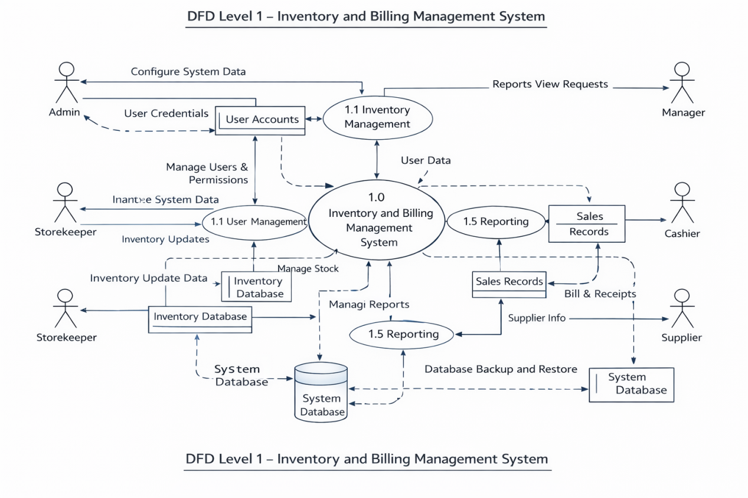
Fig 3.3 DFD level 1 diagram

DFD LEVEL 2
(Decomposition of Key Processes)

Process 1: Inventory Management

2.1 Add Item
Input: Item details (Admin/owner)
Output: Item stored confirmation
Data Store: Inventory Database

2.2 Update Item
Input: Updated item details
Output: Update confirmation
Data Store: Inventory Database

2.3 Update Stock Quantity
Input: Stock quantity details (Storekeeper)
Output: Stock update confirmation
Data Store: Inventory Database

2.4 View Inventory
Input: Inventory request
Output: Inventory list/status
Data Store: Inventory Database
This level shows how inventory operations such as adding items, updating items, updating stock quantity, and viewing inventory are handled internally using the Inventory Database.

Process 2: Billing & Sales Processing

3.1 Select Items
Input: Item selection (Cashier)
Output: Selected item list
Data Store: Inventory Database

3.2 Generate Bill
Input: Selected items
Output: Bill details
Data Store: Sales Database
3.3 Process Payment
Input: Payment information (Customer)
Output: Payment confirmation
Data Store: Sales Database

3.4 Update Stock After Sale
Input: Sold item details
Output: Updated stock quantity
Data Store: Inventory Database
DFD Level 2 for Billing & Sales Processing explains item selection, bill generation, payment processing, and automatic stock update after sales.

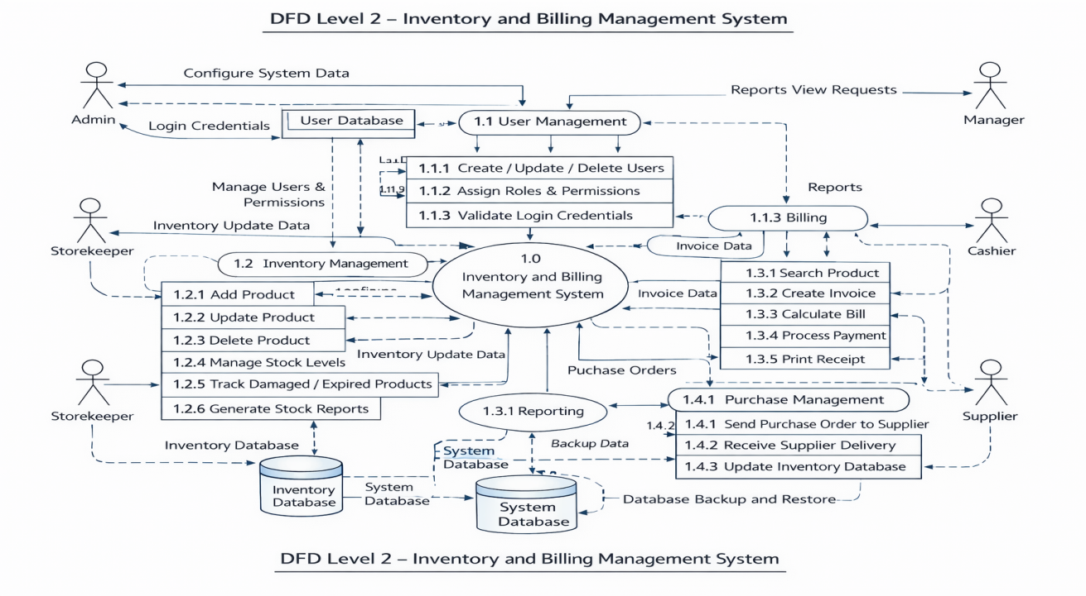

Fig 3.4 DFD level 2 diagram

4.5 Entity-Relationship Diagram (ERD)

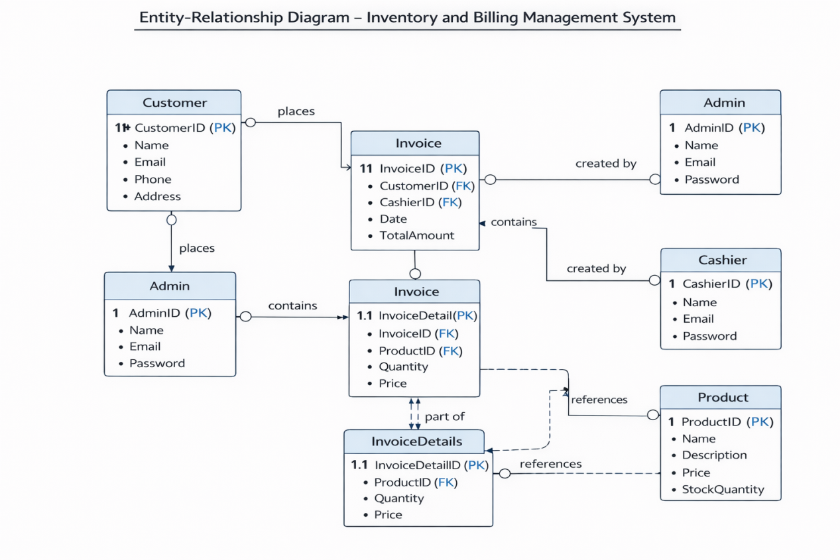
Fig 3.5 ERD

Relationships
- Customer ↔ Invoice → One-to-Many (A customer can have multiple invoices)
- Cashier ↔ Invoice → One-to-Many (A cashier can create multiple invoices)
- Invoice ↔ InvoiceDetails → One-to-Many (An invoice can have multiple products)
- Product ↔ InvoiceDetails → One-to-Many (A product can appear in multiple invoices)
4.6 Activity Diagrams
An Activity Diagram is a type of UML diagram that models the workflow of a system or process, showing the sequence of activities and decisions. It illustrates how tasks are performed and the flow of control from one activity to another. Activity diagrams are useful for visualizing business processes or system logic.
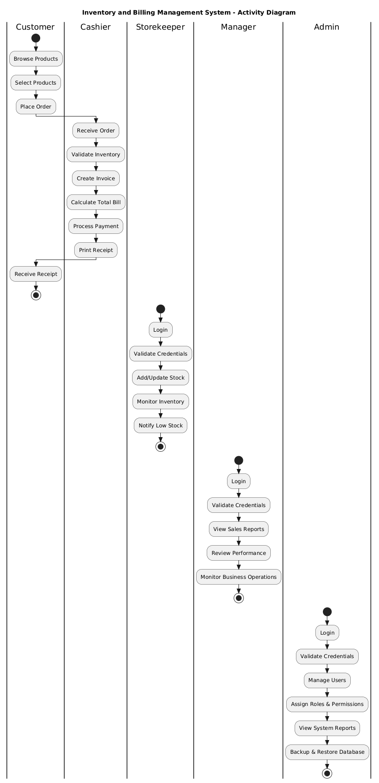
Fig 3.6 zctivity diagram
4.7 Sequence Diagrams System Design
A Sequence Diagram in system design is a type of UML diagram that shows how objects or actors interact over time to accomplish a specific task. It illustrates the sequence of messages exchanged between system components, highlighting the order of operations and interactions. Sequence diagrams are useful for modeling system behavior and workflows.

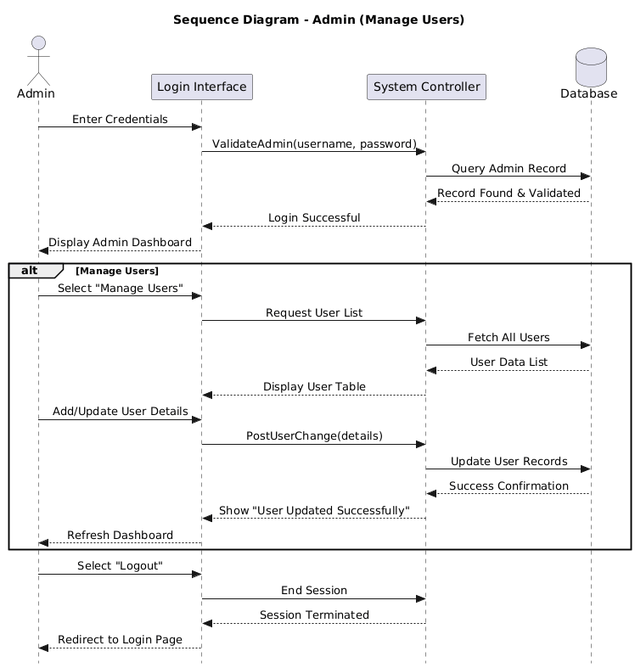

Fig 3.7 admin user sequence diagram

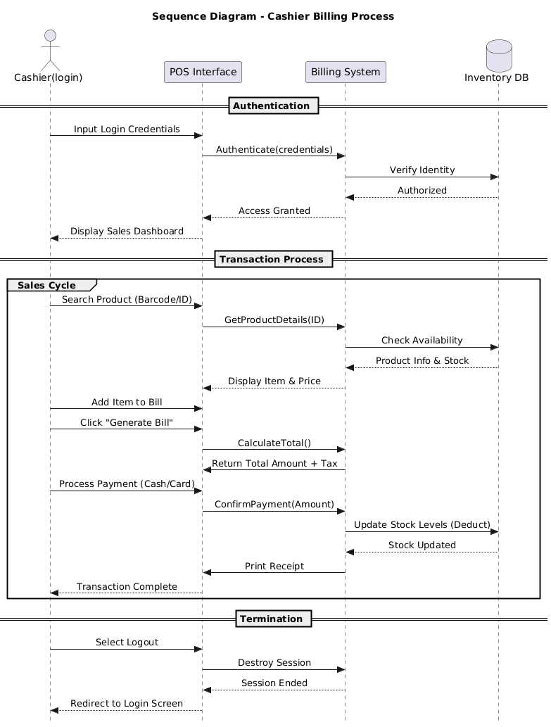

Fig 3.8 cashier user sequence diagram

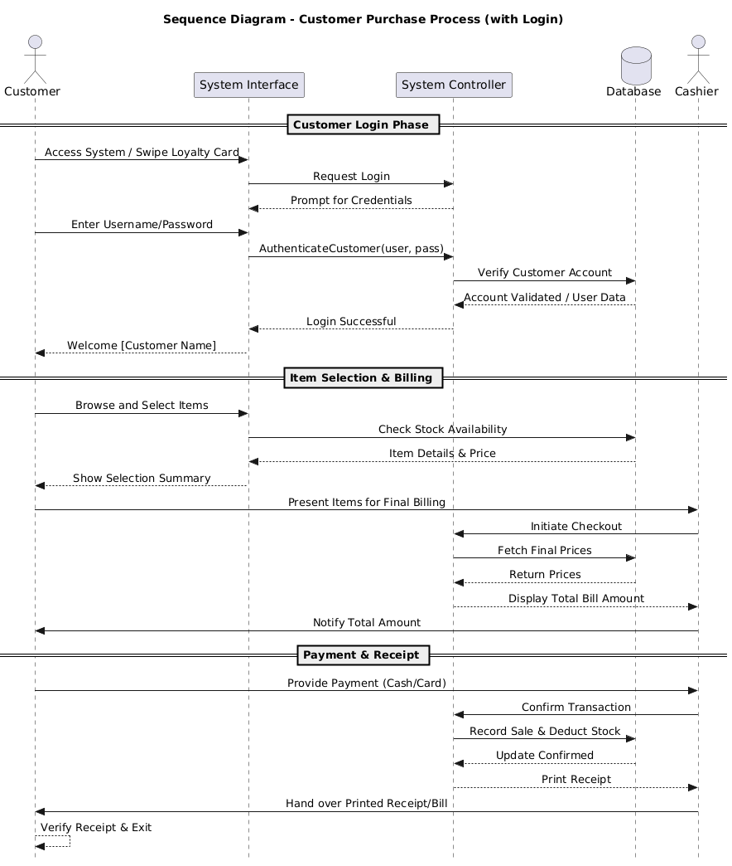

Fig 3.9 customer user sequence diagram

3.8 System Architecture
System Architecture is the structured design of a system, showing how its components interact to achieve functionality. It defines the layers, modules, and data flow between the user interface, business logic, and database. It ensures the system is scalable, maintainable, and reliable.

Architecture Type

1. Presentation Layer (Front-End)
Technology: HTML, CSS, JavaScript, Bootstrap, PHP (for dynamic pages)
Responsibility:
- Display user interface for Admin, Cashier, and Customer
- Accept user inputs (e.g., product selection, invoice creation, login)
- Send requests to the Application Layer via PHP scripts
Example Pages:
- Login Page
- Product Listing / Search Page
- Invoice Generation Page
- Report Viewing Page (Admin / Manager)

2. Application Layer (Business Logic)
Technology: PHP
Responsibility:
- Implement system rules and workflow
- Perform CRUD operations:
Create / Read / Update / Delete products, invoices, users
- Validate user inputs
- Generate reports
- Handle billing calculations and transaction management
Sub-modules:
- User Management Module
- Inventory Management Module
- Billing Module
- Reporting Module
- Purchase / Supplier Management Module

3. Data Layer (Database)
Technology: MySQL
Responsibility:
- Store all system data securely:
- Users (Admin, Cashier, Customers)
- Products / Inventory
- Invoices / Invoice Details
- Transactions / Reports
- Maintain relationships between tables (ERD)
- Support queries for reporting and billing
- Handle backup and recovery
Data Access: PHP scripts access the database using MySQL queries and prepared statements.

External Actors / Interfaces
Admin: Manages users, configures system, views reports.
Cashier: Handles billing, invoices, and payments.
Customer: Places orders, receives invoices.
Storekeeper: Manages stock levels, handles product entries, and monitors inventory health.
Manager: Monitors overall business performance, reviews sales trends, and oversees staff activity.
Supplier (Optional): Supplies products to inventory.
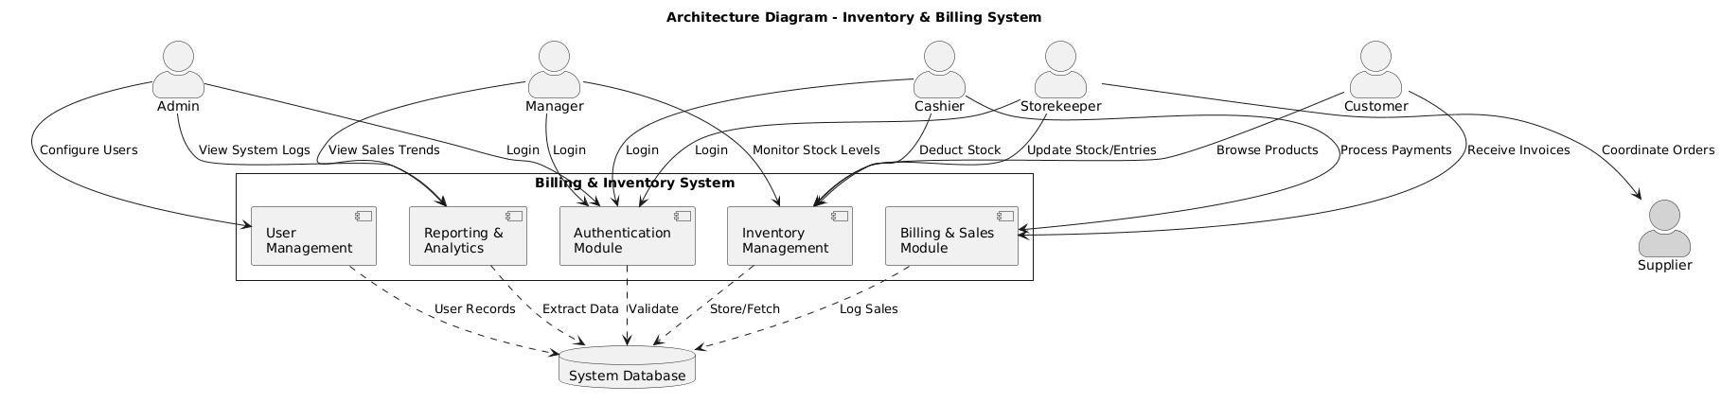
Fig 4.8.1 system archticture diagram

3.9 Class Diagram

A Class Diagram is a type of UML diagram that shows the static structure of a system, including its classes, attributes, methods, and relationships. It’s useful for modeling the system at the code level and is commonly used in system design to plan object-oriented implementation.

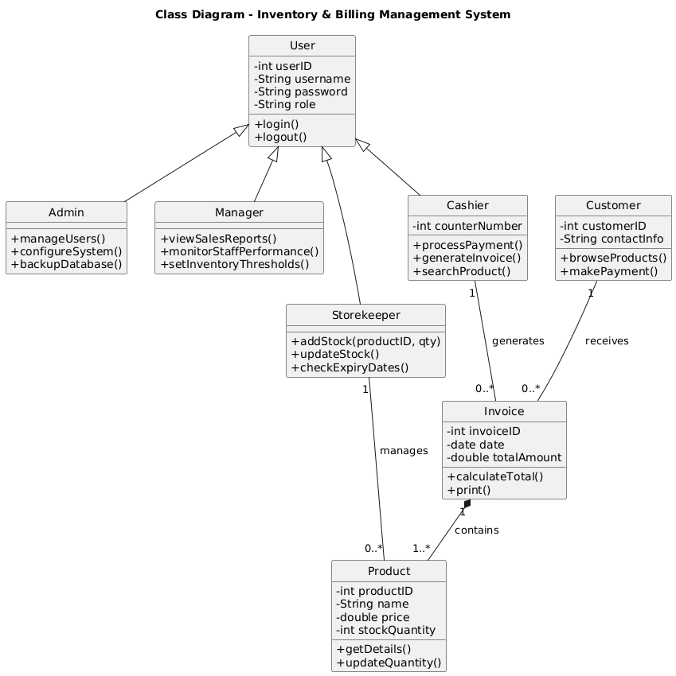
Fig 4.9.1 class diagram
3.10 Database Design
Database Design is the structured planning of how data will be organized, stored, and related to support the system’s functionality. For your project, it ensures that information about customers, users, products, invoices, and transactions is stored efficiently, maintains data integrity, and supports quick retrieval and updates.

Types of Database Design Concepts in invetory and billing management system
- Logical Design: Defines entities, attributes, and relationships like Customers ↔ Invoices ↔ Products.
- Physical Design: Specifies how data is actually stored in MySQL, including keys, constraints, and indexing.
- Normalization: Organizes data to avoid redundancy and ensure consistency (e.g., separating invoices from invoice details).
- Relationship Management: Defines how data interacts, such as Customer having multiple invoices, Invoice containing multiple products.
- Transaction & Integrity Design: Ensures billing, stock updates, and payments happen reliably and accurately.
3.11 User Interface (UI) Design

Design Principles
Simplicity: Clean layout with only necessary information displayed.
Consistency: Similar layouts, colors, and buttons across pages for easy navigation.
Responsiveness: Works on multiple devices (desktop, tablet).
User-Centric: Interfaces designed separately for Admin(Cashier),and Customer, based on tasks.

Main User Interfaces

Admin UI
Dashboard: Overview of system metrics (total sales, total customers, products in stock).
User Management Page: Add, update, delete users (Cashier/Admin).
Inventory Management Page: View and update product details, check stock.
Report Page: Generate and download sales, inventory, or transaction reports.
Navigation: Sidebar with clear menu items for each module.

Cashier UI
Login Page: Secure login for Cashier with email and password.
Product Listing Page: Search and select products to create an invoice.
Invoice Page: Display selected products, quantity, price, total amount.
Payment Page: Input payment details and confirm transactions.
Receipt Page: Display invoice details for printing or saving.

Customer UI (Optional for Online Access)
Product Browsing Page: View product catalog with search and filter.
Order Summary Page: Review selected products and total amount.
Invoice Page: View invoice after purchase.

Common UI Components
Buttons: Submit, Cancel, Print, Update, Delete
Forms: For login, user management, product input, invoice creation
Tables: Display product lists, invoices, and user lists
Navigation Bar: Consistent menu for switching between modules
Alerts & Notifications: Confirmation messages, error warnings

3.12 Data Dictionary
A data dictionary is a detailed description of all data elements in a system, including their meaning, type, and constraints.

1. User Data
Data Element | Description | Data Type | Size | Constraint | Used By
user_id | Unique identifier for system users | Integer | --- | Primary Key | Admin
full_name | Full name of the user | Varchar | 100 | Not Null | Admin
username | Login name for system access | Varchar | 80 | Unique, Not Null | Admin, Cashier
password | Encrypted password for authentication | Varchar | 200 | Not Null | Admin, Cashier
role | User role in the system | Enum | -- | owner/Cashier | System
status | Account status | Enum | -- | Active/Inactive | Admin

- Customer Data

Data Element | Description | Data Type | Size | Constraint
customer_id | Unique identifier for customer | Integer | — | Primary Key
customer_name | Customer full name | Varchar | 100 | Not Null
phone_number | Customer contact number | Integer | — | Unipue Not Null
email | Customer email address | Varchar | 100 | Optional

3. Product Data

Data Element | Description | Data Type | Size | Constraint
product_id | Unique product identifier | Integer | — | Primary Key
product_name | Name of the product | Varchar | 100 | Not Null
category | Product category | Varchar | 50 | Not Null
unit_price | Price per unit | Decimal | 10,2 | Not Null
quantity_in_stock | Available quantity | Integer | — | Not Null
status | Product availability | Enum | — | Not Null

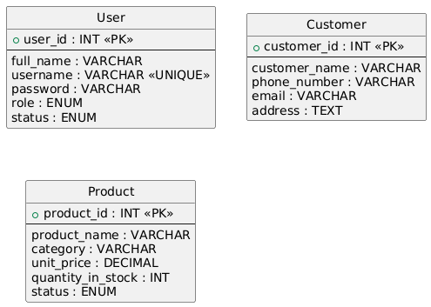

Fig 3.12 data dictionary diagram(sample)

CHAPTER FOUR

Implementation Documentation

5.1 Overview
This chapter describes how the Inventory and Billing Management System was implemented. It explains the tools and technologies used, system modules, coding standards followed, and important implementation details. The implementation phase transforms the system design into a working software application.

5.2 Tools and Technologies Used
The following tools and technologies were used to implement the system:
- Programming Language: PHP- Server-side scripting language used to implement dynamic web pages and business logic
- Database Management System: MySQL-Relational database system used to store, manage, and retrieve system data
- Frontend Technologies: HTML, CSS, JavaScript- Markup language used to structure web page content.
-Stylesheet language used to design and format the visual appearance of web pages.
-Client-side scripting language used to add interactivity and dynamic behavior to web pages.
- Web Server: Apache (XAMPP)-Web server software that hosts and runs the web application locally.
- Development Environment: Visual Studio Code-Code editor used to write, debug, and manage the project’s source code.
- Operating System: Windows-used to run the development and testing environment.
- Browser: Google Chrome -Web browser used to access and test the web application.
These tools were selected because they are open-source, easy to use, and suitable for web-based applications.

4.3 System Modules
The Inventory and Billing Management System is divided into several modules. Each module performs a specific function and works together to ensure efficient system operation. The modular approach improves system maintainability, scalability, and security.

4.3.1 Authentication Module
This module manages user access to the system.
- User login and logout
- Verification of username and password
- Session management
- Role-based access control (Admin, Staff, Manager)

4.3.2 User Management Module (Admin)
This module allows the administrator to manage system users.
- Add new users
- Update user information
- Delete user accounts
- Assign and manage user roles

4.3.3 Inventory Management Module
This module handles all inventory-related activities.
- Add new inventory items
- Update item details (name, price, quantity)
- Delete items
- View available stock
- Monitor low-stock items

4.3.4 Billing and Sales Module
This module manages billing and sales transactions.
- Create sales invoices
- Calculate total price automatically
- Generate customer bills/receipts
- Record sales transactions
- Update inventory quantity after each sale

4.3.5 Reporting Module
This module generates reports for monitoring and decision-making.
- Sales reports (daily, monthly)
- Inventory reports
- Low-stock reports
- Staff performance reports

4.3.6 Database Management Module
- This module ensures proper data storage and integrity.
- Insert, update, delete, and retrieve data
- Maintain relationships between tables
- Backup and restore database

4.3.7 System Maintenance Module
This module supports system stability and future updates.
- Error handling
- System logs
- Bug fixing and updates
Each system module performs a specific role in the Inventory and Billing Management System. Together, these modules provide secure access, efficient inventory control, accurate billing, and reliable reporting, ensuring smooth business operations.

4.4 Coding Standards
Coding standards were followed during the development of the Inventory and Billing Management System to ensure code quality, readability, consistency, security, and ease of maintenance. Adhering to proper coding standards also helps future developers understand and extend the system efficiently.

4.4.1 General Coding Guidelines
- Clear and meaningful variable, function, and file names were used.
- Code was written in a simple and understandable manner.
- Proper indentation and spacing were maintained throughout the code.
- Comments were added to explain complex logic and important sections.
- Duplicate code was minimized by reusing functions where possible.

4.4.2 PHP Coding Standards
- PHP scripts were separated from HTML where possible.
- Prepared statements were used for database operations to prevent SQL injection.
- Sessions were used securely to manage user authentication.
- Input data was validated and sanitized before processing.
- Error messages were handled properly to avoid exposing system details.

4.4.3 Database Coding Standards (MySQL)
- Meaningful table and column names were used.
- Primary keys and foreign keys were properly defined.
- Data types were chosen appropriately to ensure data integrity.
- Database normalization was applied to reduce redundancy.
- Transactions were used where necessary to maintain consistency.

4.4.4 Front-End Coding Standards
- HTML was written using proper semantic tags.
- CSS was used for styling to separate design from logic.
- JavaScript was used minimally and responsibly for client-side validation.
- User interface elements were kept consistent across all pages.

4.4.5 Security Coding Standards
- User passwords were encrypted before storing in the database.
- Role-based access control was enforced.
- Unauthorized access to system pages was restricted.
- Session timeout and logout mechanisms were implemented.

4.4.6 Documentation and Maintenance Standards
- Code files were named consistently.
- Inline comments were used for clarity.
- Code was organized into folders based on functionality.
- Changes were tested before deployment.
Following proper coding standards ensured that the Inventory and Billing Management System is secure, maintainable, scalable, and easy to understand. These standards contributed to the reliability and overall quality of the system.
4.5 Important Code Snippets
This section presents key code samples that demonstrate how major system functionalities are implemented using PHP and MySQL. These snippets highlight secure database connectivity, CRUD operations, authentication, billing transactions, and inventory updates.

Database Connection (MySQL + PHP)
This code establishes a secure connection between the system and the database.
<?php
$conn = new mysqli("localhost", "root", "", "ibms");
if ($conn->connect_error) {
die("Connection failed: " . $conn->connect_error);
}
?>
Purpose:Ensures reliable communication between the application and the database.

User Login Authentication
Used to authenticate Admin or Cashier users.
<?php
session_start();
$username = $_POST['username'];
$password = $_POST['password'];
$query = "SELECT * FROM user WHERE username=?";
$stmt = $conn->prepare($query);
$stmt->bind_param("s", $username);
$stmt->execute();
$result = $stmt->get_result();
if ($row = $result->fetch_assoc()) {
if (password_verify($password, $row['password'])) {
$_SESSION['role'] = $row['role'];
header("Location: dashboard.php");
} else {
echo "Invalid password";
}
}
?>
Purpose:Prevents unauthorized access and ensures role-based system usage.

Insert New Product (Create Operation)
Adds new products to inventory.
<?php
$sql = "INSERT INTO product (product_name, category, unit_price, quantity_in_stock, status)
VALUES (?, ?, ?, ?, ?)";
$stmt = $conn->prepare($sql);
$stmt->bind_param("ssdis", $name, $category, $price, $qty, $status);
$stmt->execute();
?>
Purpose:Allows Admin to manage inventory efficiently.

Display Products (Read Operation)
Fetches product data for display.
<?php
$result = $conn->query("SELECT * FROM product");
while ($row = $result->fetch_assoc()) {
echo $row['product_name'] . " - " . $row['unit_price'] . "<br>";
}
?>
Purpose:Displays real-time inventory information.

Update Product Stock (Update Operation)
Automatically updates stock after sales.
<?php
$update = "UPDATE product
SET quantity_in_stock = quantity_in_stock - ?
WHERE product_id = ?";
$stmt = $conn->prepare($update);
$stmt->bind_param("ii", $sold_qty, $product_id);
$stmt->execute();
?>
Purpose:Maintains accurate stock levels.

Delete Product (Delete Operation)
Removes obsolete products.
<?php
$delete = "DELETE FROM product WHERE product_id=?";
$stmt = $conn->prepare($delete);
$stmt->bind_param("i", $product_id);
$stmt->execute();
?>
Purpose:Keeps inventory data clean and updated.

Invoice Creation with Transaction Management
Ensures billing and stock update happen together.

<?php
$conn->begin_transaction();
try {
$conn->query("INSERT INTO invoice (invoice_date, total_amount) VALUES (NOW(), $total)");
$invoice_id = $conn->insert_id;
$conn->query("UPDATE product SET quantity_in_stock = quantity_in_stock - $qty WHERE product_id = $product_id");
$conn->commit();
} catch (Exception $e) {
$conn->rollback();
echo "Transaction Failed";
}
?>

Purpose: Guarantees data consistency during billing operations.

8. Logout Function
Ends the user session securely.

<?php

session_start();

session_destroy();

header("Location: login.php");

?>
Purpose:Protects system security by clearing user sessions.

Generaly
These code snippets demonstrate:
- Secure database connectivity
- Authentication and authorization
- Full CRUD operations
- Transaction handling for billing
- Inventory stock management
They collectively prove the practical implementation of the Inventory and Billing Management System.

CHAPTER FIVE

TESTING DOCUMENTATION

5.1 Test Plan

5.1.1 Introduction
Software testing is an essential phase of system development that ensures the quality, reliability, and correctness of a software system. A test plan provides a systematic approach to identifying defects and verifying that the system meets the specified requirements.
This Test Plan describes the testing approach, objectives, scope, resources, and schedule for the Inventory and Billing Management System. The purpose is to ensure that the system functions correctly, reliably, and meets all specified requirements before deployment.

5.1.2 Objectives of Testing
- Verify that all system functionalities work as intended
- Identify and fix errors before system deployment
- Ensure data accuracy in inventory and billing operations
- Validate system performance, security, and usability

5.1.3 Scope of Testing
- The testing covers the following system modules:
- User Authentication (Login/Logout)
- Product Management
- Inventory Stock Control
- Billing and Invoice Generation
- Database Operations (CRUD)
- Backup and Recovery

5.1.4 Testing Types Included
- Unit Testing
- Integration Testing
- System Testing
- User Acceptance Testing (UAT)

5.1.5 Testing Approach
Testing is conducted using a black-box testing approach, which focuses on validating system functionality by examining inputs and outputs without considering internal code structure. Testing is mainly performed manually with basic validation techniques.

5.1.6 Test Environment
Hardware:
- Desktop or Laptop Computer
- Minimum 4GB RAM
Software:
- Operating System: Windows
- Web Server: Apache (XAMPP)
- Database: MySQL
- Programming Language: PHP
- Browser: Chrome or Firefox

5.1.7 Test Data
- Test data includes:
- Sample product records
- Dummy user accounts
- Sample billing transactions
- Invalid, boundary, and duplicate input values

5.1.8 Roles and Responsibilities
- Tester: Executes test cases and reports defects
- Developer: Fixes identified bugs
- Project Supervisor: Reviews testing activities and results

5.1.9 Entry and Exit Criteria
Entry Criteria:
- All system modules are implemented
- Database setup is completed and operational
Exit Criteria:
- All critical defects are resolved
- Test cases execute successfully
- System meets defined functional requirements

5.1.10 Test Deliverables
- Test Plan Document
- Test Case Documents
- Test Execution Reports
- Bug and Issue Reports

5.1.11 Testing Schedule
Activity | Duration
Test Planning | 1 Day
Unit Testing | 2 Days
Integration Testing | 1 Day
System Testing | 1 Day
User Acceptance Testing | 1 Day

5.1.12 Risks and Mitigation
Risk: Incomplete or unclear requirements
Mitigation: Review and clarify requirements before testing
Risk: Limited testing time
Mitigation: Focus on critical and high-risk system modules

TC-13 | Save billing record | Bill generated | Billing details | Bill stored in database

5.2 Test Cases
Test cases are designed to verify that each function of the Inventory and Billing Management System performs according to the specified requirements. Each test case includes test conditions, input data, and expected results to ensure accurate and reliable system behavior.

5.2.1 User Authentication Test Cases

Test Case ID | Test Description | Precondition | Input Data | Expected Result
TC-01 | Login with valid credentials | User account exists | Valid username & password | User is logged into the system
TC-02 | Login with invalid credentials | User account exists | Invalid username or password | Error message displayed
TC-03 | Login with empty fields | Login page loaded | Empty username/password | Validation warning shown
TC-04 | Logout from system | User logged in | Click logout button | User session terminated

5.2.2 Product Management Test Cases
Test Case ID | Test Description | Precondition | Input Data | Expected Result
TC-05 | Add new product | Admin logged in | Product name, quantity, price | Product added successfully
TC-06 | Add product with missing data | Admin logged in | Empty fields | Error message displayed
TC-07 | Update product details | Product exists | Updated quantity/price | Product updated successfully
TC-08 | Delete product | Product exists | Product ID | Product removed from system

5.2.3 Inventory Stock Control Test Cases

Test Case ID | Test Description | Precondition | Input Data | Expected Result
TC-09 | Reduce stock after billing | Product in stock | Sold quantity | Stock updated correctly
TC-10 | Prevent negative stock | Low stock product | Quantity greater than stock | Transaction rejected

5.2.4 Billing and Invoice Test Cases

Test Case ID | Test Description | Precondition | Input Data | Expected Result
TC-11 | Generate bill | Products selected | Product list & quantities | Bill generated successfully
TC-12 | Calculate total amount | Products selected | Prices & quantities | Correct total calculated

5.2.5 Database Operation Test Cases

Test Case ID | Test Description | Precondition | Input Data | Expected Result
TC-14 | Insert record | Database connected | Valid data | Valid data
TC-15 | Retrieve record | Data exists | Query request | Correct data displayed
TC-16 | Update record | Record exists | Updated values | Record updated
TC-17 | Delete record | Record exists | Record ID | Record deleted

5.2.6 Backup and Recovery Test Cases
Test Case ID | Test Description | Precondition | Input Data | Expected Result
TC-18 | Backup database | Database available | Backup command | Backup file created
TC-19 | Restore database | Backup file exists | Restore command | Database restored successfully
All test cases are executed and compared against expected results. The system is considered stable and reliable when all critical test cases pass successfully.

5.3 Unit Testing
Unit testing is the process of testing individual components or modules of a system independently to ensure that each unit functions correctly according to the design specifications. In the Inventory and Billing Management System, unit testing is performed on the smallest functional parts of the system before integrating them into the complete system.
The primary objective of unit testing is to detect errors at an early stage of development, reduce system defects, and ensure that each module performs its intended task accurately.

5.3.1 Units Tested
- The following system units are tested individually:
- User Authentication Module
- Product Management Module
- Inventory Stock Control Module
- Billing Module
- Database Connection Module

5.3.2 Unit Testing Approach
Unit testing is conducted using a white-box testing approach, where internal logic, conditions, and control flows of each module are examined. Testing is performed manually by the developer using predefined test data.

5.3.3 Unit Test Cases

a) User Authentication Module
Test Case ID | Test Description | Input | Expected Result
UT-01 | Validate correct login | Valid username & password | Login successful
UT-02 | Validate incorrect login | Invalid credentials | Error message displayed
UT-03 | Check empty fields | Empty inputs | Validation message shown

b) Product Management Module

Test Case ID | Test Description | Input | Expected Result
UT-04 | Add product | Product details | Product saved successfully
UT-05 | Update product | Updated data | Product updated correctly
UT-06 | Delete product | Product ID | Product deleted

c) Inventory Stock Control Module
Test Case ID | Test Description | Input | Expected Result
UT-07 | Reduce stock | Sold quantity | Stock reduced correctly
UT-08 | Prevent negative stock | Quantity > available

d) Billing Module
Test Case ID | Test Description | Input | Expected Result
UT-09 | Calculate bill total | Price & quantity | Correct total calculated
UT-10 | Save billing record | Billing data | Record stored successfully

e) Database Connection Module

Test Case ID | Test Description | Input | Expected Result
UT-11 | Establish DB connection | Valid DB credentials | Connection successful
UT-12 | Handle connection failure | Invalid credentials | Error message displayed

5.4 Integration Testing
Integration testing is the process of testing combined system modules to verify that they interact correctly with each other. After successful unit testing, individual modules of the Inventory and Billing Management System are integrated and tested as a group to identify interface defects and data flow issues between modules.
The main objective of integration testing is to ensure that integrated components work together seamlessly and exchange data accurately.

5.4.1 Modules Integrated
- The following modules are integrated and tested:
- User Authentication and Product Management
- Product Management and Inventory Stock Control
- Inventory Stock Control and Billing Module
- Billing Module and Database
- Backup and Recovery Module with Database

5.4.2 Integration Testing Approach
Integration testing is performed using an incremental testing approach, where modules are integrated step by step and tested after each integration. A black-box testing method is applied to verify data flow and functional behavior between modules.

5.4.3 Integration Test Cases

Test Case ID | Integrated Modules | Test Description | Expected Result
IT-01 | Login + Product Module | Access product page after login | Access granted
IT-02 | Product + Inventory | Update stock after product edit | Stock updated correctly
IT-03 | Inventory + Billing | Update stock after product edit | Stock reduced correctly
IT-04 | Billing + Database | Save bill data | Bill stored successfully
IT-05 | Backup + Database | Backup after transactions | Backup completed successfully

5.4.4 Integration Testing Result
All integrated modules function correctly and exchange data as expected. No major interface or data flow errors are observed after integration testing.

5.5 System Testing
System testing is conducted to evaluate the complete and fully integrated Inventory and Billing Management System as a whole. The purpose of system testing is to verify that the system satisfies all functional and non-functional requirements specified in the Software Requirements Specification (SRS).
Unlike unit and integration testing, system testing focuses on the overall behavior of the system under real operating conditions.

5.5.1 Objectives of System Testing
- Verify end-to-end system functionality
- Ensure accuracy of inventory and billing operations
- Validate system performance and reliability
- Confirm system security and data integrity
- Ensure the system is user-friendly

5.5.2 System Testing Environment
System testing is performed in an environment similar to the real deployment environment.
- Hardware:
- Desktop or Laptop Computer
- Minimum 4GB RAM
- Software:
- Operating System: Windows
- Web Server: Apache (XAMPP)
- Database: MySQL
- Programming Language: PHP
- Browser: Chrome

5.5.3 System Test Cases

Test Case ID | Test Description | Input | Expected Result
ST-01 | Complete user login process | Valid credentials | User logged in successfully
ST-02 | Add and manage products | Product details | Products managed correctly
ST-03 | Generate bill and update stock | Sales data | Correct bill & stock update
ST-04 | Save and retrieve billing records | Billing details | Accurate data displayed
ST-05 | Handle invalid inputs | Incorrect data | Error messages displayed
ST-06 | Perform backup and recovery | Backup file | Data restored successfully

5.5.4 Non-Functional Testing
- Performance Testing:
System responds within acceptable time for all operations.
- Security Testing:
Unauthorized access is restricted through login authentication.
- Usability Testing:
System interface is simple and easy to use.

5.5.5 System Testing Result
The system operates as expected under normal and abnormal conditions. All critical functions perform correctly, and no major defects are found during system testing.

5.6 User Acceptance Testing (UAT)
User Acceptance Testing (UAT) is the final phase of testing in which the system is evaluated by end users to ensure that it meets their business requirements and expectations. The purpose of UAT is to confirm that the Inventory and Billing Management System is ready for real-world use.
UAT is conducted after successful completion of unit, integration, and system testing.

5.6.1 Objectives of UAT
- Validate system functionality from the user’s perspective
- Ensure the system meets business and operational requirements
- Confirm ease of use and user satisfaction
- Identify any remaining issues before deployment

5.6.2 UAT Participants
- Store Manager / Administrator
- Cashier or Sales Staff
- Project Supervisor (Observer)

5.6.3 UAT Environment
UAT is conducted in a real-like environment using actual system configuration.
- Web-based system accessed via browser
- MySQL database with sample operational data
- Authorized user accounts

5.6.4 UAT Test Cases
Test Case ID | User Role | Test Scenario | Expected Result
UAT-01 | Admin | Login and manage products | Successful access and updates
UAT-02 | Admin | View inventory stock | Accurate stock displayed
UAT-03 | Cashier | Generate bill | Correct bill generated
UAT-04 | Cashier | Print or save invoice | Invoice saved/printed
UAT-05 | Admin | Backup and restore data | Data recovered successfully

5.6.5 Acceptance Criteria
The system is accepted if:
- All critical UAT test cases pass
- Users confirm the system is easy to use
- No major functional issues remain

5.6.6 UAT Result
All UAT test cases are executed successfully. Users confirm that the Inventory and Billing Management System meets their requirements and is ready for deployment.

CHAPTER SIX

DEPLOYMENT DOCUMENTATION

6.1 Installation Guide
The installation guide provides step-by-step instructions for installing and configuring the Inventory and Billing Management System. Proper installation ensures that the system runs correctly and efficiently in the target environment.

6.1.1 System Requirements
- Hardware Requirements:
- Desktop or Laptop Computer
- Minimum 4GB RAM
- At least 10GB free disk space
- Software Requirements:
- Operating System: Windows
- Web Server: Apache (XAMPP)
- Database Server: MySQL
- Programming Language: PHP
- Web Browser: Chrome or Firefox

6.1.2 Pre-Installation Steps
- Ensure the computer meets all hardware and software requirements.
- Install XAMPP on the system.
- Start Apache and MySQL services from the XAMPP control panel.

6.1.3 System Installation Steps
- Copy the project folder (InventoryBillingSystem) into the htdocs directory of XAMPP.
- Open a web browser and navigate to http://localhost/phpmyadmin.Create a new database named inventory_system.
- Import the provided SQL file into the database.
- Configure the database connection file (db.php) with correct database credentials.

6.1.4 System Configuration
- Ensure file permissions are correctly set.
- CVerify database connection settings.
- onfigure admin and user login credentials.

6.1.5 Running the System
- Open a web browser.
- Enter the URL: http://localhost/InventoryBillingSystem.
- Login using authorized credentials.
- Verify that the system dashboard loads successfully.

6.1.6 Post-Installation Verification
Confirm that all system modules load correctly.
Test basic functions such as login, product management, and billing.
Verify database connectivity and data storage.

6.1.7 Installation Completion
The installation process is considered successful when the system runs without errors and all core functionalities operate as expected.

6.2 Deployment Diagram
A deployment diagram illustrates the physical architecture of the system and shows how software components are deployed on hardware nodes. It describes the relationship between client devices, server, database, and system components in the Inventory and Billing Management System.
The deployment diagram helps in understanding how the system is installed, executed, and accessed in a real operational environment.

6.2.1 Deployment Architecture Description
The Inventory and Billing Management System follows a web-based client–server architecture consisting of the following nodes:
- Client Machine
- Web Server
- Database Server

6.2.2 Deployment Nodes
1. Client Node
- Hardware: Desktop or Laptop
- Software: Web Browser (Chrome/Firefox)
- Role: Allows users (Admin, Cashier) to access the system interface
2. Web Server Node
- Software: Apache Web Server (XAMPP)
- Application: PHP-based Inventory and Billing System
- Role: Processes user requests, business logic, and communicates with the database
3. Database Server Node
- Software: MySQL
- Role: Stores inventory data, billing records, user accounts, and transaction data

6.2.3 Deployment Diagram Description
The Deployment Diagram illustrates the physical architecture of the Inventory and Billing Management System and shows how software components are deployed across hardware nodes and how these nodes communicate with each other.
The system follows a client–server architecture, where users interact with the system through a web browser. The application is hosted on a web server that processes user requests using PHP scripts. All persistent data is stored in a centralized MySQL database server.

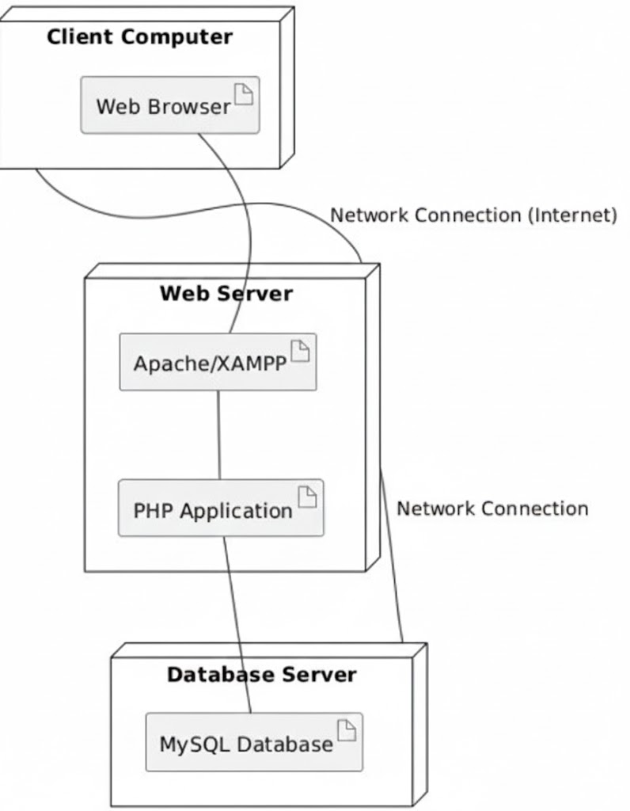

Fig 6.1.1 deployment diagram

6.2.4 Communication Flow
- User accesses the system using a web browser on the client machine.
- Requests are sent to the web server via HTTP.
- The web server processes requests using PHP scripts.
- The web server interacts with the MySQL database to retrieve or store data.
- The response is sent back to the client browser for display.

6.2.5 Deployment Summary
The deployment structure ensures secure communication between users and the system, efficient data processing, and reliable data storage. This architecture supports scalability and ease of maintenance.

6.3 Backup and Recovery Plan
The Backup and Recovery Plan defines the procedures used to protect system data and ensure quick restoration in case of data loss, system failure, or accidental deletion. This plan is essential for maintaining data integrity and system availability in the Inventory and Billing Management System.

6.3.1 Backup Objectives
- Prevent loss of critical inventory and billing data
- Ensure business continuity in case of system failure
- Provide a reliable method for data restoration

6.3.2 Data to Be Backed Up
- The following data components are included in the backup process:
- Product and inventory records
- Billing and transaction data
- User account information
- Database schema and configuration files

6.3.3 Backup Method
- Backup Type: Full Database Backup
- Backup Tool: MySQL Dump
- Backup Format: .sql file
- Backup Location: Local system or external storage device
Backups are performed by exporting the MySQL database using standard backup tools.

6.3.4 Backup Schedule
Backup Type | Frequency
Full Backup | Daily
Manual Backup | Before major updates

6.3.5 Backup Procedure
- Open Command Prompt or Terminal.
- Navigate to the MySQL bin directory.
- Execute the backup command:
- Verify that the backup file is created successfully.

6.3.6 Recovery Procedure
- In case of data loss or system failure, the following steps are used to restore data:
- Ensure MySQL service is running.
- Open Command Prompt or Terminal.
- Execute the restore command
- Verify that all data is restored correctly.
6.3.7 Recovery Testing
Recovery procedures are tested periodically to ensure that backup files can be restored successfully and data integrity is maintained.

6.3.8 Backup and Recovery Responsibility
System Administrator: Performs and manages backups
Developer: Assists in recovery during system failure
Project Supervisor: Reviews backup and recovery practices

6.3.9 Backup and Recovery Conclusion
The backup and recovery plan ensures that the Inventory and Billing Management System remains secure, reliable, and recoverable in case of unexpected failures or data loss.

CHAPTER SEVEN

USER MANUAL

7.1 How to Use the System (with Screenshots)
This user manual provides step-by-step instructions on how to use the Inventory and Billing Management System. The system is designed to be user-friendly and can be operated by authorized users such as administrators and cashiers.

7.1.1 Accessing the System
- Open a web browser (Chrome or Firefox).
- Enter the system URL: http://localhost/InventoryBillingSystem
- The login page will be displayed.
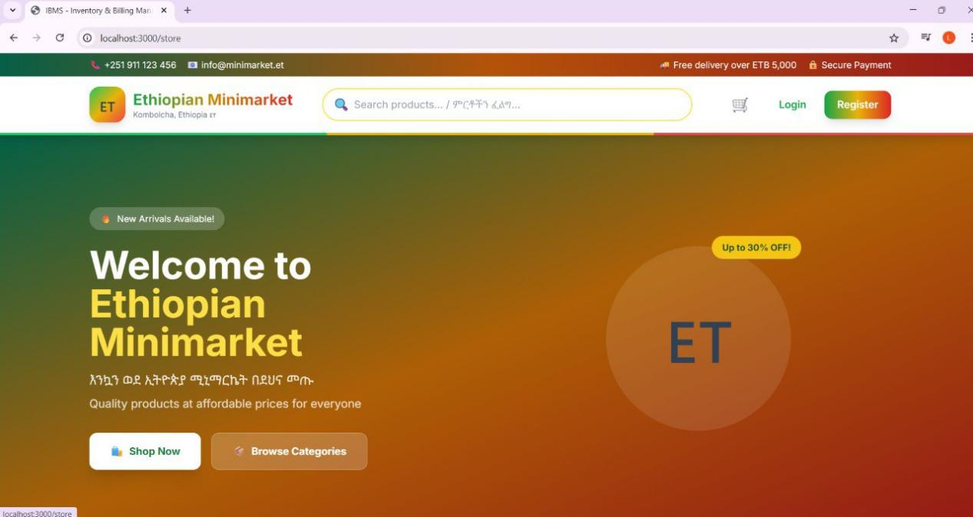
Screenshot 8.1: Login Page

7.1.2 User Login
- Enter your username and password.
- Click the Login button.
If the credentials are valid, the system dashboard will open.
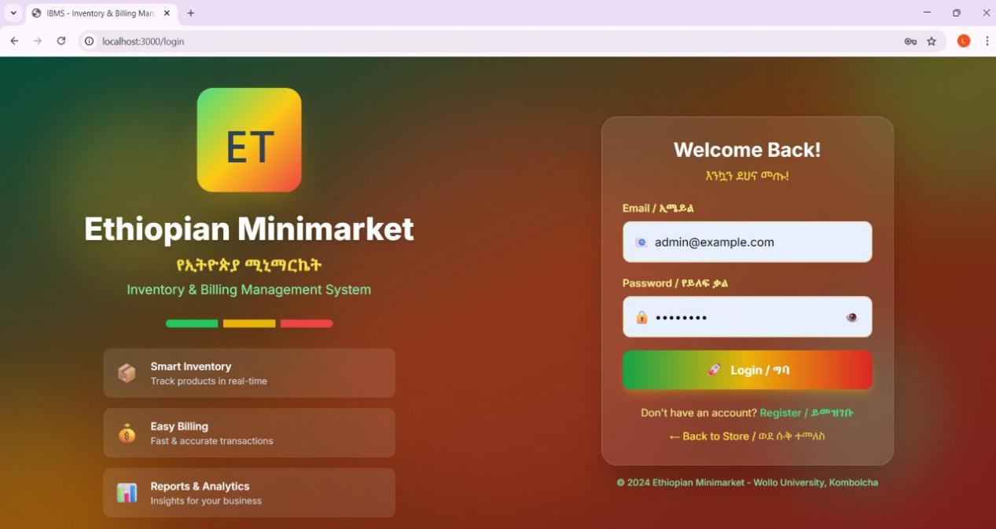
Screenshot 8.2: User Login Form
Note: If invalid credentials are entered, an error message will be displayed.

7.1.3 Dashboard Overview
After successful login, the dashboard is displayed. It provides access to major system functions such as:
- Product Management
- Inventory Management
- Billing
- Reports
- Logout
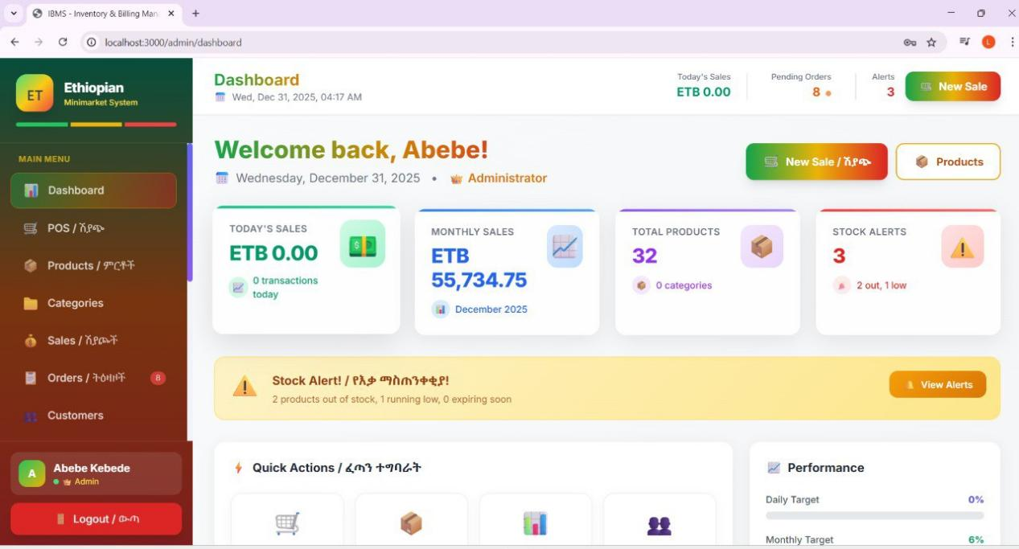
Screenshot 8.3: System Dashboard

7.1.4 Managing Products
To Add a Product:
- Click on Products from the dashboard menu.
- Enter product name, quantity, and price.
- Click Add Product.
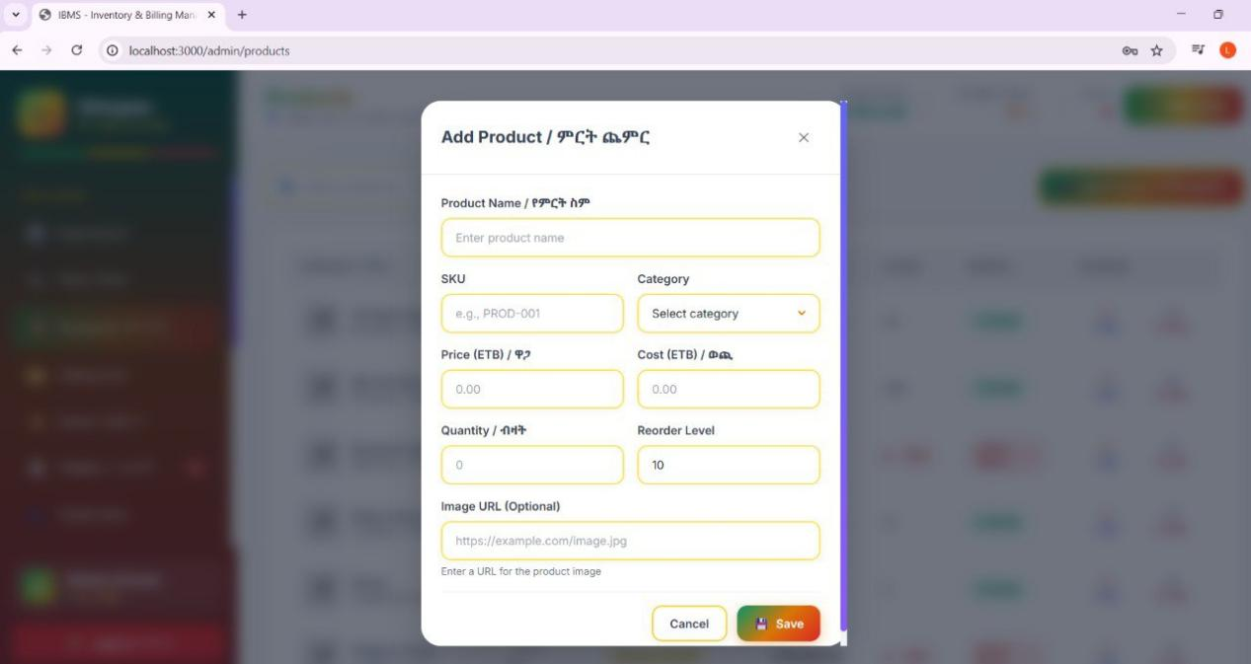
Screenshot 8.4: Add Product Page
To Update or Delete a Product:
- Select the product from the list.
- Click Edit to update or Delete to remove the product.
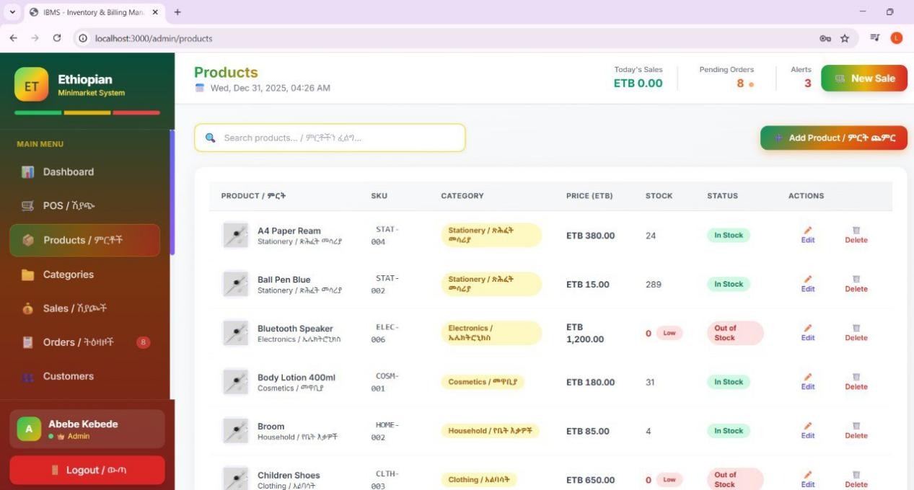
Screenshot 8.5: Product List Page

7.1.5 Inventory Management
- Click Inventory from the menu.
- View available stock levels for all products.
- Low-stock items are highlighted for attention.
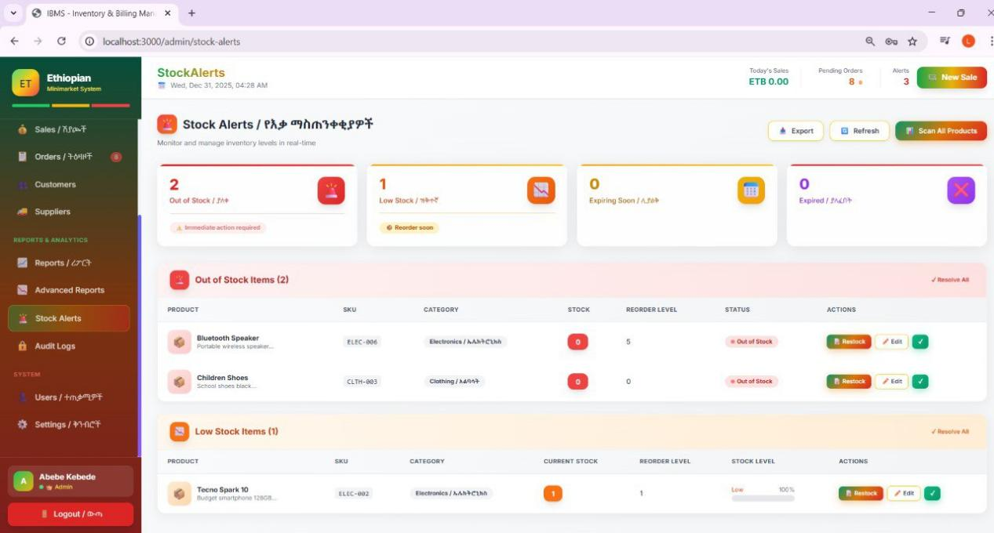
Screenshot 8.6: Inventory Stock Page

7.1.6 Billing and Invoice Generation
- Click Billing from the dashboard.
- Select products and enter quantities.
- The system automatically calculates the total amount.
- Click Generate Bill to save the transaction.
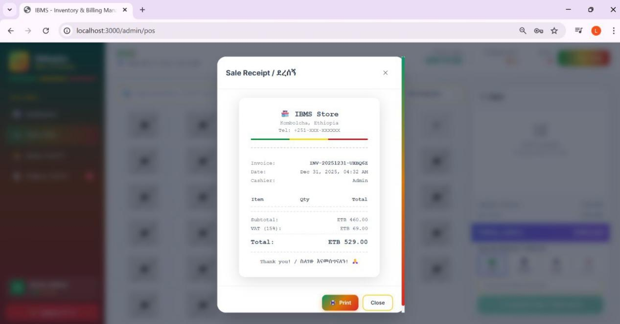
Screenshot 8.7: Billing Page

7.1.7 Viewing Billing Records
- Navigate to Billing History or Reports.
- View previously generated bills and transaction details.
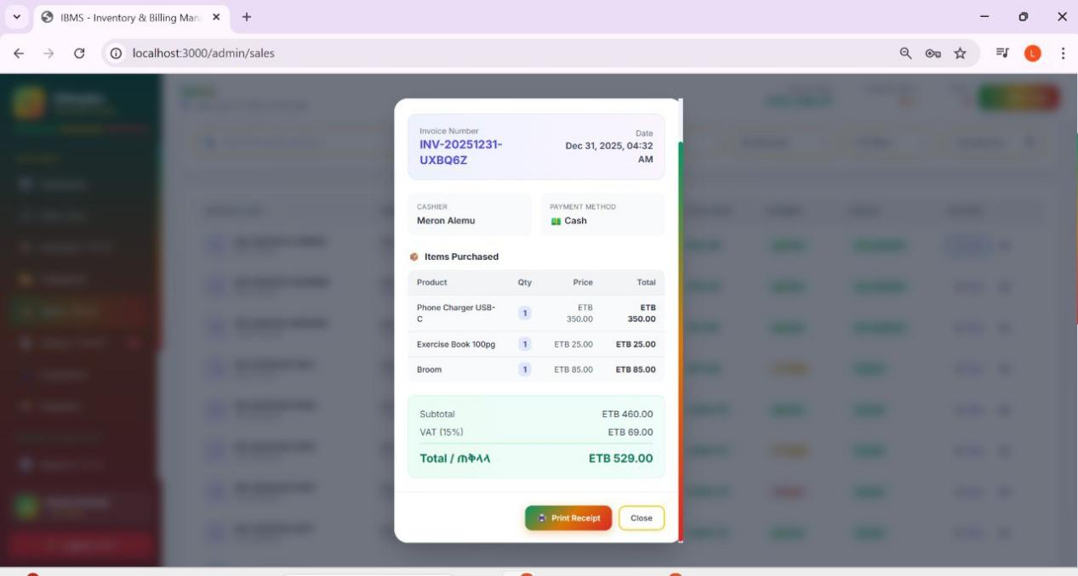
Screenshot 8.8: Billing Records Page

7.1.8 Backup and Recovery (Admin/Owner Only)
- Login as an administrator.
- Go to System Settings or Backup option.
- Click Backup Database to create a backup file.
- Use Restore option to recover data when needed.
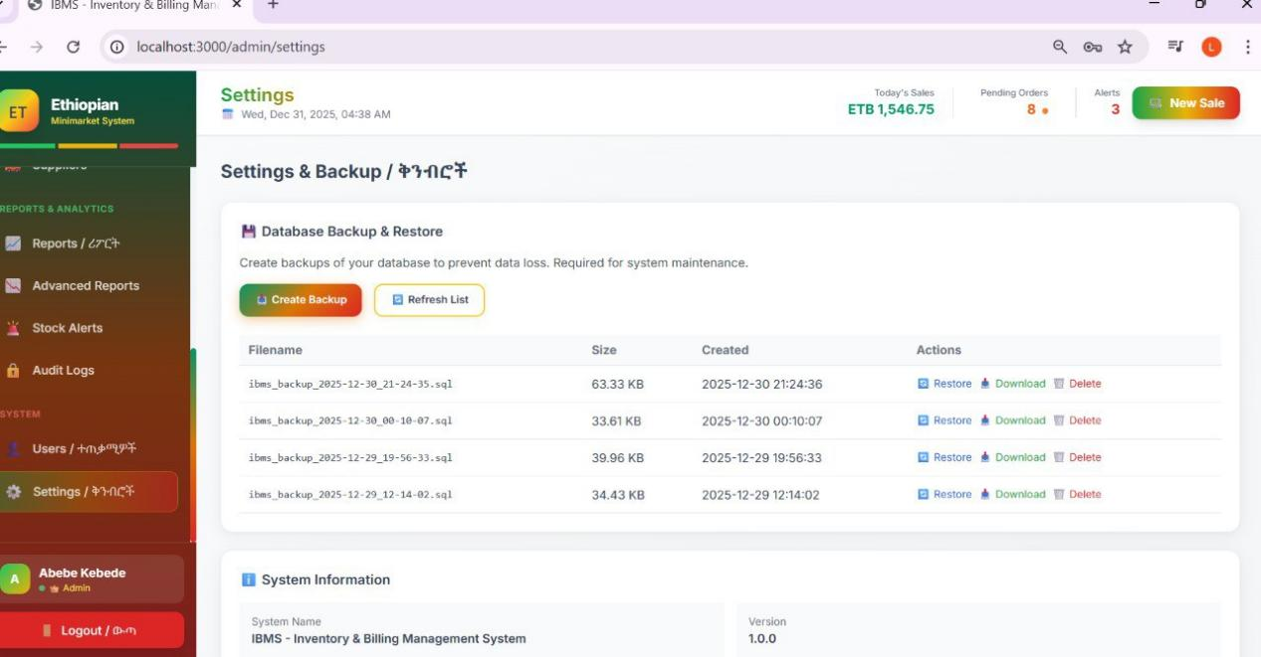
Screenshot 8.9: Backup and Recovery Page

7.1.9 Logout from the System
- Click the Logout button on the dashboard.
- The system ends the session and redirects to the login page.
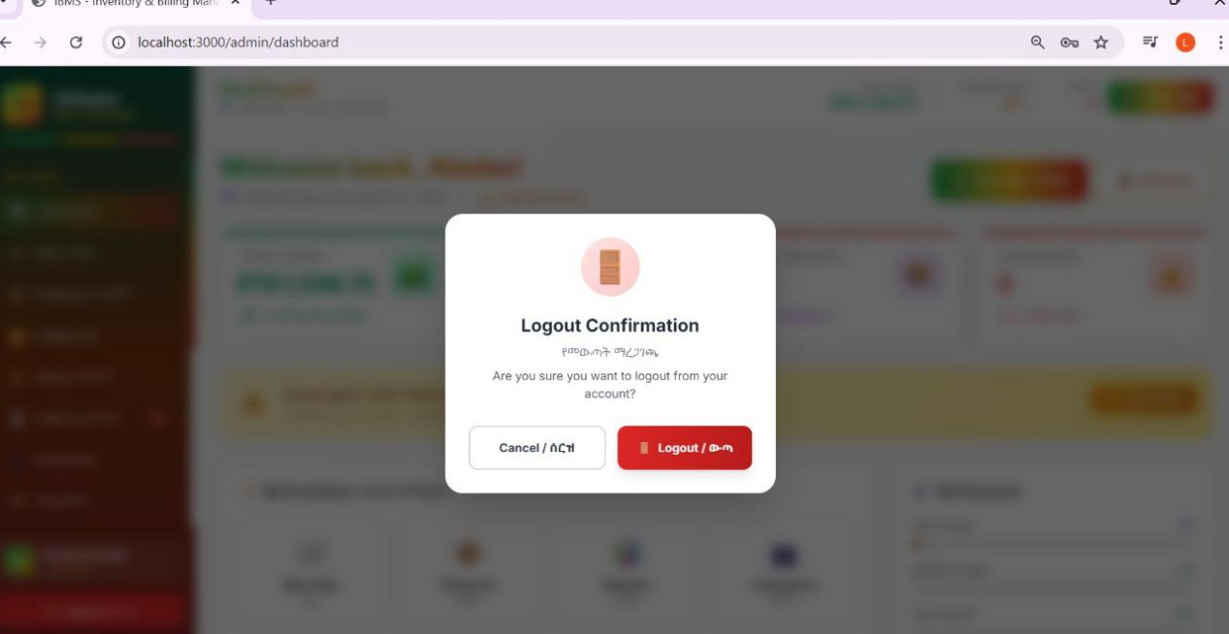
Screenshot 8.10: Logout Confirmation

7.1.10 User Manual Conclusion
The Inventory and Billing Management System is simple to operate and provides efficient management of products, inventory, and billing operations. By following the steps outlined above, users can effectively utilize all system features.

CHAPTER EIGHT

MAINTENANCE DOCUMENTATION

8.1 System Maintenance
System maintenance refers to the activities required to keep the Inventory and Billing Management System running efficiently after deployment. Maintenance ensures that the system remains reliable, secure, and adaptable to future requirements.

8.2 Types of Maintenance
The system maintenance activities include the following types:

8.2.1 Corrective Maintenance
Corrective maintenance is performed to fix errors or bugs discovered during system operation. This includes:
- Fixing login or authentication issues
- Correcting calculation errors in billing
- Resolving database connection problems

8.2.2 Preventive Maintenance
Preventive maintenance is carried out to reduce the risk of future system failures. This includes:
- Regular database backups
- System performance monitoring
- Updating security configurations

8.2.3 Adaptive Maintenance
Adaptive maintenance involves modifying the system to work with new environments or requirements, such as:
- Updating the system for new operating systems or browsers
- Adjusting database configurations
- Modifying system features based on user needs

8.2.4 Perfective Maintenance
Perfective maintenance focuses on improving system performance and usability. This includes:
- Enhancing user interface design
- Improving system response time
- Adding minor features requested by users

8.3 System Update and Bug-Fix Procedures
- Identify and document the reported issue.
- Analyze the cause of the problem.
- Modify the relevant source code or database structure.
- Test the fix in a test environment.
- Deploy the update to the live system.
- Verify system functionality after update.

8.4 Maintenance Tools
The following tools are used for system maintenance:
- PHP and MySQL tools
- XAMPP Control Panel
- Web Browser (for testing)
- Database backup utilities

8.5 Maintenance Responsibility
System Administrator: Performs backups, monitors system performance
Developer: Fixes bugs and implements updates
Project Supervisor: Reviews maintenance activities

8.6 Maintenance Schedule

Maintenance Activity | Frequency
Database Backup | Daily
Bug Fixing | As needed
System Update | Monthly
Performance Review | Quarterly

8.7 Maintenance Conclusion
Proper maintenance ensures that the Inventory and Billing Management System continues to operate smoothly, securely, and efficiently. Regular maintenance activities help extend system lifespan and improve user satisfaction.

CHAPTER NINE

CONCLUSION & FUTURE WORK

9.1 Overview
The Inventory and Billing Management System was developed to automate and simplify inventory control and billing operations. The system provides features such as user authentication, product management, inventory tracking, billing and invoice generation, database backup, and recovery.
Throughout the project, system analysis, design, implementation, testing, deployment, and maintenance activities were carried out successfully. The system improves data accuracy, reduces manual workload, and enhances efficiency in managing inventory and billing processes.

9.2 Limitations of the System
Despite its benefits, the system has some limitations:
- The system is designed for small to medium-scale businesses only
- Internet connection is required for web-based access
- Advanced security features such as encryption are limited
- Report generation features are basic

9.3 Recommendations and Future Work
To enhance the system in the future, the following improvements are recommended:
- Implement advanced security features such as data encryption
- Add detailed sales and inventory reporting tools
- Integrate barcode scanning for faster billing
- Develop a mobile-friendly or mobile application version
- Enable cloud-based deployment for remote access

9.4 Conclusion
The Inventory and Billing Management System successfully meets its intended objectives and provides a reliable solution for managing inventory and billing operations. With future enhancements, the system can be expanded to support larger organizations and more advanced functionalities.

CHAPTER TEN

APPENDICES
The appendices section provides supporting materials that complement the main project documentation. These materials include additional diagrams, sample data, system forms, and important code excerpts used in the development of the Inventory and Billing Management System.

10.1 Appendix A: Additional Diagrams
This appendix contains diagrams that support system understanding and design, including:
- Use Case Diagram
- Entity Relationship Diagram (ERD)
- Data Flow Diagrams (DFD Level 0, Level 1, Level 2)
- Deployment Diagram

10.2 Appendix B: Sample Data
Sample data is used for testing and demonstration purposes during system development.
Sample Product Data:
Product ID | Product Name | Quantity | Price
1 | Laptop | 20 | 50000
2 | Mouse | 15 | 400
3 | Keyboard | 25 | 1000

Sample User Data:
User ID | Username | Role
1 | admin | Administrator
2 | cashier | Cashier

10.3 Appendix D: Code Appendix
The following are important code excerpts used in the system implementation.
Database Connection (PHP):
<?php$conn = mysqli_connect("localhost", "root", "", "inventory_system");if (!$conn) {
die("Connection failed: " . mysqli_connect_error());
}?>
Product Insertion Query:
INSERT INTO products (product_name, quantity, price)VALUES ('Laptop', 10, 45000);
Billing Calculation Logic (PHP):
$total = $quantity * $price;

10.4 Appendix Conclusion
The appendices provide additional technical and reference information that supports the design, implementation, and testing of the Inventory and Billing Management System. These materials enhance clarity and serve as useful references for future development and maintenance.
References:
Nixon, R. (2021). Learning PHP, MySQL & JavaScript: With Case Studies in Web App Development (6th ed.). O'Reilly Media.
Match: This supports your use of PHP for server-side logic and MySQL for the database.
Ullman, L. (2016). PHP and MySQL for Dynamic Web Sites: Visual QuickPro Guide. Peachpit Press.
Match: Matches your objective to "design a dynamic web application using PHP".
Silberschatz, A., Korth, H. F., & Sudarshan, S. (2019). Database System Concepts (7th ed.). McGraw-Hill.
Match: Supports your implementation of a Relational Database and the creation of ER Diagrams.
DuBois, P. (2014). MySQL (5th ed.). Addison-Wesley Professional.
Match: Directly relates to your use of MySQL for secure data storage and retrieval.
Sommerville, I. (2015). Software Engineering (10th ed.). Pearson.
Match: This is the standard text for Software Engineering concepts mentioned in your abstract.
Pressman, R. S., & Maxim, B. R. (2019). Software Engineering: A Practitioner's Approach (9th ed.). McGraw-Hill Education.
Match: Provides the academic basis for the Waterfall Development Model you utilized.
Muller, M. (2019). Essentials of Inventory Management (3rd ed.). AMACOM.
Match: Provides the business logic for stock levels, low-stock alerts, and inventory tracking mentioned in your functional requirements.

